SEBI

BULLETIN

NOVEMBER 2020 VOL. 18 NUMBER 11

(LOGO)

SECURITIES AND EXCHANGE BOARD OF INDIA

EDITORIAL COMMITTEE

Shri Amarjeet Singh

Dr. Prabhakar R. Patil

Shri Prabhas Rath

Ms. Deepthi L.S.

Dr. Deepali Dixit

Shri Jitendra Kumar

The Securities and Exchange Board of India Bulletin is issued by the Department of Economic and Policy Analysis, Securities and Exchange Board of India under the direction of an Editorial Committee. SEBI is not responsible for accuracy of data/information/interpretations and opinions expressed in the case of signed articles/speeches as authors are responsible for their personal views. SEBI has no objection to the material published herein being reproduced, provided an acknowledgement of the same is made. A readable version of SEBI Bulletin is available at http://www.sebi.gov.in. Further, soft copy of SEBI Bulletin is available free of cost to the subscribers/readers, who register at bulletin@sebi.gov.in along with their complete address. Any comments and suggestions on any of the features/sections may be sent to bulletin@sebi.gov.in

CONTENTS

CHAIRMAN’S SPEECH ON CII 11th FINANCIAL MARKETS SUMMIT

CAPITAL MARKET REVIEW

REVIEW OF GLOBAL FINANCIAL MARKETS

HIGHLIGHTS OF DEVELOPMENTS IN INTERNATIONAL SECURITIES MARKET

POLICY DEVELOPMENTS AT SEBI

REGULATORY ACTIONS TAKEN BY SEBI

TABLES

PUBLICATIONS

CII 11th Financial Markets Summit

“Rebooting economy through financial market reforms”

October 21, 2020

- Ladies and Gentlemen, I would like to thank CII for giving me the opportunity to share my thoughts on the subject with you.
- Before I move on to subject of financial markets, it may be important to address something more fundamental i.e. the meaning of ‘reform’ itself. Generally speaking, whenever the term ‘reform’ is used, one immediately thinks of radical changes; something involving a complete overhaul of the system. Examples of such reforms in the capital markets in India would perhaps include - moving from an open outcry system to electronic trading system; and moving from physical shares to demat shares of corporates.
- However, such a notion of reforms is highly restrictive. In real sense, the reforms even include the incremental changes made from time to time with a view to improving the system.
- Another ‘misconception’ when we think of reforms, is that there has to be some existing major problem for the said ‘reform’ to take place. ‘Reform’ is almost always thought of as fixing a broken system. While it may be certainly true in certain cases, it is not always necessary to be so. Reforms could simply be preventive in nature.

Approach of SEBI towards reforms

- Let me now briefly touch upon SEBI’s approach towards reforms. Our endeavor has been to be a progressive, open minded and forward looking regulator – to constantly introspect, interact with stakeholders, learn from experiences, follow best global practices and quickly adapt to changes.
- The most important element of our approach is the consultative process. This is achieved through two major ways:
- Firstly, we have several expert Committees, having wide and varied stakeholder representation, which provide us with inputs on major policy reforms. As on today, we have 13 Standing Committees and many other specific-purpose Committees as constituted from time to time.
- Secondly, with regard to policy issues, we typically prepare consultation papers and invite public comments on the same. These public comments are analyzed in detail before taking a view. We take this consultation process seriously as we believe that the same is very much required to improve the robustness of policy making process.

The increasingly consultative approach of SEBI is demonstrated by the fact that around 100 consultation papers on policy reform measures were issued by SEBI during the last 5 years. In this financial year alone, we have issued 27 consultation papers.

Role and Place of Capital markets in Indian Financial sector

- The financial sector in India is dominated by bank lending. This needs urgent diversification by facilitating fund raising through capital markets, especially considering the well-known problems with the banking sector. Also, some investments are best funded through the capital markets. For instance, it would be a challenging task to achieve the Government’s target of having ` 100 lakh crore investments in infrastructure by 2024-25 unless the bond market is adequately developed.
- The fund raising, both equity and debt combined, through capital markets in the last 2-3 years has averaged around ` 9 - 9.5 lakh crore per year. Though it sounds impressive, the same needs much ramp up considering the needs of a developing economy.
- The capital markets work on the principle of dis-intermediation; i.e. by directly bringing together the issuers and investors. Clearly, this can work only if all relevant disclosures are readily made available by borrowers to investors so that they could take their decisions after analyzing risk and return of the investment. Trust of fair play and faith in the regulatory system is of utmost importance for capital markets to thrive and sustain. This being the defining principle, much of the efforts of the regulator go in ensuring the same.

Present Scenario
- We are indeed going through very difficult and challenging times. The June quarter saw a 23.9% drop in the GDP in India over the same quarter last fiscal. The RBI expects a 9.5% drop in the GDP in this financial year. It is not just India but the entire world which is going through a recession phase. While different agencies project different numbers for the global GDP forecasts for this year, everyone agrees that the global economy will surely contract in a major way.
- In this backdrop, I would now like to briefly touch upon the recent performance of capital markets in India.

Secondary Markets

- First, let us take the secondary market movements. Immediately following the declaration of pandemic in the month of March 2020, the markets reacted adversely. The lower circuit breaker was triggered on two occasions within a span of just two weeks – an occurrence which has never happened in the past. The Volatility Index VIX went up to 84 in March from an average of 15 in the previous 3 months. SEBI took some timely surveillance measures with respect to exposures and margins to curb volatility. The markets have recovered well since then. The Sensex/Nifty today is very close to the all-time high hit in January 2020. The volatility has also relatively stabilized with the VIX now hovering around 25.
- While one repeatedly hears that the liquidity and low interest rates are the only prime factors driving up the markets, and that there is a disconnect between the market and the real economy, I would like to place before you certain positive aspects of the market recovery, so far.
- We have observed that the recovery in the market has been broad-based. Our analysis reflects this fact on three counts. Firstly, it is not just the large cap but also the mid and small cap indices which have recovered since the lows hit in March 2020. While the large cap and mid cap indices have increased around 55%, the small cap index has increased around 70%. Secondly, while statistically the indices could go up because of certain stocks which have relatively higher weights, our analysis shows that the recovery is not only in the heavy weight stocks, but is across the board in the index. Around 40-50% of the constituents in each index category- large, mid and small cap- outperformed the respective indices this financial year. Thirdly, the recovery is broad-based outside the indices as well- out of the stocks that have traded on NSE and BSE during this financial year, more than 93% of the stocks on NSE and more than 75% of the stocks on BSE have yielded positive returns in this financial year as on Sep 30, 2020.
- Let us now examine the participation of investors. On a broader level, the participation in the equity market is higher now than ever before. The average daily turnover in the cash market in this financial year is around ` 60,000 crore, 54% higher than the figure of ` 39,000 crore last year. The equity derivatives segment has also seen the average daily turnover grow by around 27% as compared to the last year. In fact, the average daily turnover in both the cash market and equity derivatives hit their all-time high figures in the months of June and September 2020.
- On specific investor level as well, the participation is quite high. I have already commented on the trend of increasing retail participation in the markets in my earlier public addresses. To update the position, during April- September 2020, 63 lakh new demat accounts were added as compared to 27.4 lakh accounts during the corresponding period last year, i.e. an increase by around 130 %.
- On the FPI front, we have received around $11 billion of net FPI investments in the equity markets in this financial year till date. Interestingly, while most of the Emerging Markets including Brazil, Taiwan, South Korea, Thailand, South Africa and Malaysia have witnessed FPI outflows in the calendar year 2020 so far, India has witnessed net FPI inflows during the same period.
- On the mutual fund side, after initial outflows in March 2020 especially in the debt schemes, we have subsequently seen, on an overall basis, net inflows of around ` 1.47 lakh crore in this financial year till September 2020.

Primary Markets

- Let us now turn to primary markets. On the equity side, despite a late start this financial year on account of COVID shock, the total funds raised have touched ` 1.54 lakh crore till September 2020, just short of ` 1.58 lakh crore raised during the corresponding period last year. Almost all of the IPOs, rights issues, etc. in this year have been over-subscribed several times. Further, more than ` 22,000 crore equity issuances are in the pipeline.
- On the debt side, the funds raised through corporate bonds this financial year till September 2020 are around ` 3.8 lakh crore which is in fact around 25% higher the funds raised in the corresponding period last year.

Reforms undertaken by SEBI

- ‘Self-praise is no recommendation’ goes the saying. While one should follow that adage, it may not be an exaggeration to say that SEBI’s policy measures have somewhat contributed in facilitating rather satisfactory working of both the primary and secondary markets in these gloomy and uncertain times.
- I need not elaborate on the measures taken by SEBI post COVID as the same are in public domain and most of them have already been discussed at length at various forums and by the media. While many of them were specific to dealing situations in COVID times, we also undertook several reforms of permanent nature. For instance, with respect to fund raising activities, we undertook reforms in rights issue regulations in line with our continual efforts to enhance the framework since last year. These include relaxation of eligibility criteria for fast track issuances, rationalisation of disclosures, relaxation from minimum subscription requirements, etc.
- Similarly, while we introduced relaxed pricing norms for preferential allotment for all companies for a specific period to address pandemic situation, we also introduced permanent relaxation from the pricing norms for preferential allotment by stressed companies. This relaxation for stressed companies is also accompanied by an exemption from open offer requirement thereby reducing the funding pressure on the prospective investors in such companies.
- Thus we broadly followed a two pronged approach post March - firstly, helping on urgent basis the companies struggling during the pandemic and secondly, continuing and accelerating our efforts to bring in long lasting reforms.
- We are also acutely aware of the possibilities of increase in volatility in the markets going forward in these uncertain times - both on account of global as well as local factors. We are and will continue to be vigilant for any rapid movements in the market and with regard to any issues which may have systemic implications.
- You may well ask whether there is any need for a radical reform in capital markets. While, as I said earlier, the term ‘radical’ may have different connotations, broadly speaking, we are of the view that the ‘development of corporate bond market’ is an area which needs deeper structural and regulatory changes. This requires coordination amongst the Government and financial sector regulators. I have already expressed my views on the subject in my earlier public addresses and may not repeat here. Also, on its part, SEBI has initiated a number of measures to develop the corporate bond market.
- Of course, considering that today’s conference is on the topic of financial market reforms, we would be eagerly waiting for its recommendations on various issues for initiating further improvements.

Role of other stakeholders in financial market reforms

- While I talked about the reforms brought in by SEBI, it begs the question as to why the term ‘reforms’ has almost always been associated with the government or the regulators. We believe that the other stakeholders need to play equally important role in reforming the financial markets. I would like to identify three specific stakeholders in this regard:
- Industry bodies:

Industry bodies such as CII have a very important role to play in financial market reforms. And when I say industry bodies, I also include associations of intermediaries and funds. The industry bodies can and should endeavor to self-regulate and set standards for themselves. Any sincere effort in this regard would enhance the confidence of other stakeholders in the market.

I recall that CII had come out with voluntary guidelines for corporate governance way back in 1998 even before SEBI prescribed clause 49 in the Listing Agreement. That was a commendable effort. If I understand correctly, those guidelines have also been recently updated.

We have amongst us Sh. Uday Kotak, who chaired SEBI’s expert committee on Corporate Governance which gave its recommendations about three years back. All of us benefitted from the Committee’s report and a number of amendments in SEBI’s LODR regulations have been brought in as a result of that. With Sh. Kotak at the helm of CII, I am sure that the industry would introspect, set higher corporate governance standards for themselves and contribute in economic development, especially in these difficult times.
- Board of Directors:

The Board of a company is an institution which is relied upon by all the stakeholders including the company’s shareholders, employees, regulators, etc. to steer the company in the right direction. The Board has tremendous powers under both the Companies Act and SEBI Regulations.

The independent directors especially represent the voices of the minority shareholders and as such are an important institution in itself. We have observed an increasing trend in the number of resignations by independent directors since the last 2-3 years. If any such resignation is on account of some governance concern, considering the role of and expectations from independent directors, I urge the resigning directors to come forward and state the same clearly to the public at large.
- Shareholders:

Shareholders have been provided several rights under the Companies Act and SEBI Regulations. More powers have been given to minority shareholders over the years especially with provisions pertaining to special resolution and majority of minority voting. This is even more relevant in the Indian context, with corporates having concentrated holding structures.

Institutional investors have emerged as the significant shareholders in the corporates. We have mandated the Stewardship Code for mutual funds and AIFs. IRDAI and PFRDA have also prescribed the same for the entities regulated by them. The shareholding institutions need to play more active role in voting on resolutions. They owe it in turn to their unit holders/investors in their fiduciary capacity.

With e-voting, voting has never been easier. I therefore urge all the shareholders – both institution and retail- to exercise their voting rights and participate in the decision making by the company.

- Apart from these stakeholders, there are others as well who can play important role in financial market reforms and act as gatekeepers of governance. These include auditors, rating agencies, trustees, proxy advisors, etc. I would like to impress upon all of the stakeholders to work towards making our financial markets more robust.

Conclusion

- A well-functioning, deep and robust financial market is a must for economic development. ‘Reform’ is a continuous process and is best brought in consultation with all stakeholders. Rather than believing that ‘crisis begets radical reforms’, I am of the view that we should continuously endeavor to keep improving our systems so that crisis, in fact, begets no radical reforms.

Thank you.

CAPITAL MARKET REVIEW

- Trends in Resource Mobilisation by Corporates

Table 1: Fund Mobilisation by Corporates (₹crore)
Particulars | Sep-20 | Oct-20
A. Funds Mobilisation through Public Issue (I+II) | 1,821.3 | 6,740.6
I. Equity Public Issue | 1,671.6 | 6,440.6
a. IPOs (i+ii) | 1,308.9 | 5,887.1
i. Main Board | 1,302.0 | 5,824.9
ii. SME Platform | 6.9 | 62.3
b. FPOs | - | -
c. Equity Right Issue | 362.7 | 553.5
II. Debt Public Issue | 149.7 | 300.0
B. Funds Mobilisation through Private Placement | 73,410.5 | 66,475.3
1. QIP/IPP | 1,337.9 | 2,200.0
2. Preferential Allotment | 7,684.0 | 1,944.5
3. Private Placement of Debt | 64,388.7 | 62,330.8
Total Funds Mobilised (A+B) | 75,231.8 | 73,215.9
Source: SEBI, NSE, BSE and MSEI

- During October 2020, there were six Main Board IPO issuances, three rights issues and eight SME issuances, mobilising ₹5,824.9 crore, ₹553.5 crore, and ₹62.3 crore respectively.
- There was one public issue of corporate bond, amounting to ₹300 crore during October 2020.
- The amount raised through private placement of equity (i.e., preferential allotment and QIP route) dipped to ₹4,144.5 crore during October 2020, against ₹9,021.9 crore during September 2020.
- Private placement of corporate debt reported on BSE and NSE stood at ₹62,330.8 crore during October 2020, compared to ₹64,388.7 crore in September 2020.

- Trends in the Secondary Market

- At the end of October 2020, Nifty 50 closed at 11,642, registering an increase of 3.5 per cent as compared to the 11,248 level at the end of September 2020.
- S&P BSE Sensex closed at 39,614 at the end of October 2020, registering an increase of 4.1 per cent as compared to the 38,068 level at the end of September 2020.
- Both, Nifty 50 and S&P BSE Sensex reached their intraday high for the month, on October 14, 2020 with closing values of 11,971 and 40,795 respectively and their intraday low for the month, on October 1, 2020 with closing values of at 11,417 and 38,697 respectively.
- The P/E ratios of S&P BSE Sensex and Nifty 50 were 27.6 and 31.9, respectively, at the end of October 2020 compared to 29.3 and 32.5, respectively, at the end of September 2020.

Table 2: Snapshot of Indian Capital Market
Description | Sep-20 | Oct-20 | Per centage Change Over Month
Index in Equity Market
Sensex | 38,068 | 39,614 | 4.1
Nifty 50 | 11,248 | 11,642 | 3.5
Nifty 500 | 9,342 | 9,582 | 2.6
BSE 500 | 14,851 | 15,215 | 2.5
Nifty Bank | 21,452 | 23,901 | 11.4
Nifty IT | 19,951 | 20,917 | 4.8
BSE Healthcare | 19,799 | 19,258 | -2.7
BSE FMCG | 11,051 | 10,923 | -1.2
Market Capitalisation (₹ crore)
BSE | 1,55,24,267 | 1,57,92,250 | 1.7
NSE | 1,53,04,722 | 1,55,87,903 | 1.9
P/E Ratio
Sensex | 29.3 | 27.6 | -6.0
Nifty 50 | 32.5 | 31.9 | -2.0
No. of Listed Companies
BSE | 5,428 | 5,437 | 0.2
NSE | 1,946 | 1,959 | 0.7
Gross Turnover in Equity Segment (₹ crore)
BSE | 70,025 | 57,866 | -17.4
NSE | 12,23,329 | 10,98,884 | -10.2
Gross Turnover in Equity Derivatives Segment (₹ crore)
BSE | 2,726,567 | 3,392,512 | 24.4
NSE | 4,74,54,518 | 5,52,81,624 | 16.5
Gross Turnover in Currency Derivatives Segment (₹ crore)
BSE | 4,29,477 | 4,08,891 | -4.8
NSE | 11,20,074 | 9,77,668 | -12.7
MSEI | 6,889 | 9,075 | 31.7
Gross Turnover in Interest Rate Derivatives Segment (₹ crore)
BSE | 619 | 1,949 | 215.0
NSE | 7,968 | 5,969 | -25.1

Figure 1: Movement of S&P BSE Sensex and Nifty 50 during October 2020
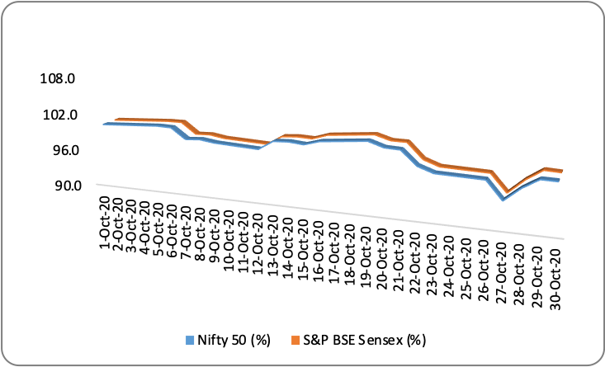
Note: The closing values of Nifty 50 and Sensex have been rebased with respective closing values of first day of the month.

- The market capitalisation of BSE and NSE registered an increase of 1.7 per cent and 1.9 per cent, respectively, over the level at the end of last month.

Figure 2: Trends in Average Daily Values of Nifty 50 and NSE Equity Cash Segment Turnover
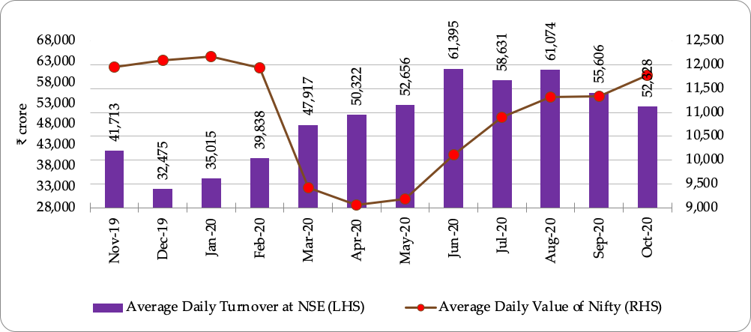

- During October 2020, the gross turnover in the equity cash segments, both at BSE and NSE, declined by 17.4 per cent and 10.2 per cent, respectively.

Figure 3: Trends in Average Daily Values of S&P BSE Sensex and BSE Equity Cash Segment Turnover
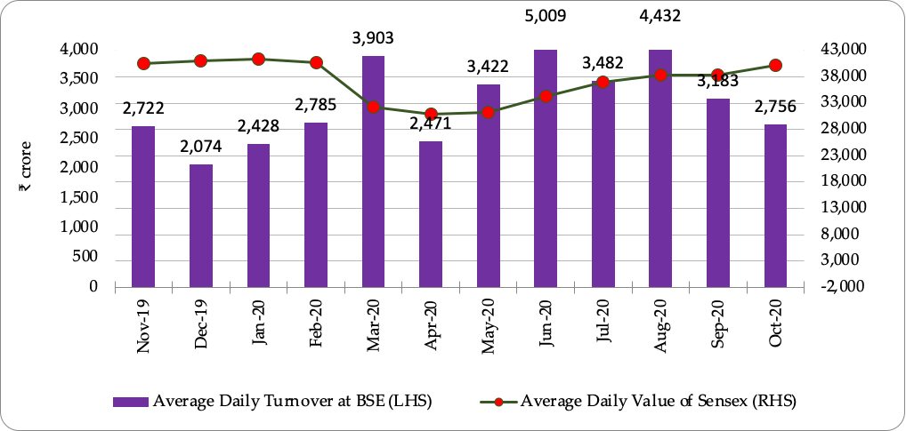

- During October 2020, majority of the BSE indices posted positive returns, of which S&P BSE Bankex increased by 12.5 per cent, followed by S&P BSE TECk (4.9 per cent), and S&P BSE Power (4.6 per cent). S&P BSE Healthcare contracted the most during the month with 2.7 per cent fall in the index value. The average daily volatility and monthly returns of BSE sectoral indices for October 2020 are illustrated in Figure 4.

Figure 4: Performance of BSE Indices during October 2020 (per cent)
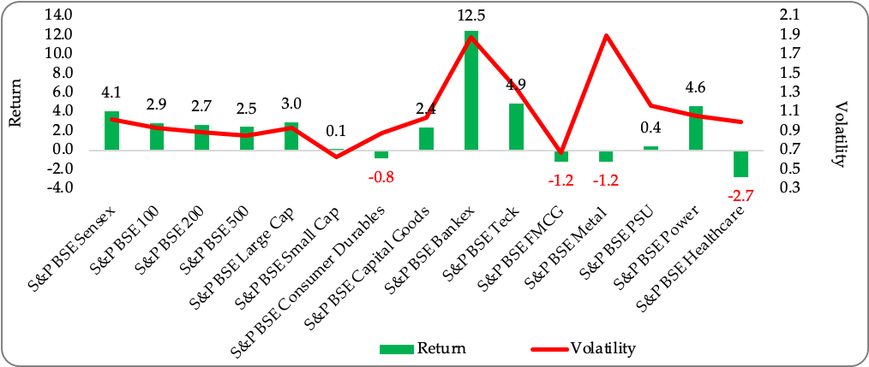

- Similarly, majority of the NSE indices posted positive returns, of which Nifty Bank and Nifty IT gained 11.4 per cent and 4.8 per cent, respectively, over September 2020. Nifty Media posted the highest decline during the month with 8.3 per cent decrease in the index value. The average daily volatility and monthly returns of NSE sectoral indices for October 2020 are illustrated in Figure 5.

Figure 5: Performance of NSE Indices during October 2020 (per cent)
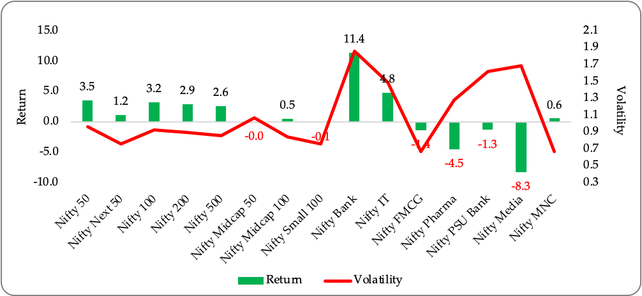

- Trends in Depository Accounts

- At the end of October 2020, there were 206 lakh demat accounts at NSDL and 270 lakh demat accounts at CDSL. Further, till the end of October 2020, 5,651 listed companies were signed up with NSDL and 5,734 listed companies were signed up with CDSL to make their equity holdings available in dematerialised form.

- Trends in Derivatives Segment

- Equity Derivatives
Table 3: Trends in Equity Derivatives Market
Description | NSE |  |  | BSE
 | Sep-20 | Oct-20 | Per centage Change Over Month | Sep-20 | Oct-20 | Percentage Change Over Month
A. Turnover (₹crore)
(i) Index Futures | 7,40,669.3 | 7,39,099.3 | (0.2) | 786.6 | 699.6 | (11.1)
(ii) Options on Index
Put | 2,01,83,965.6 | 2,38,56,847.2 | 18.2 | 7,32,822.9 | 16,51,682.5 | 125.4
Call | 2,27,65,319.6 | 2,70,46,687.9 | 18.8 | 19,92,957.1 | 17,40,130.1 | (12.7)
(iii) Stock Futures | 15,35,447.6 | 14,46,063.8 | (5.8) | - | - | -
(iv) Options on Stock
Put | 6,52,074.1 | 6,47,436.3 | (0.7) | - | - | -
Call | 15,77,042.2 | 15,45,489.8 | (2.0) | - | - | -
Total | 4,74,54,518.4 | 5,52,81,624.3 | 16.5 | 27,26,566.6 | 33,92,512.3 | 24.4
B. No. of Contracts
(i) Index Futures | 1,11,61,701 | 1,06,31,893 | (4.7) | 8,832 | 7,543 | (14.6)
(ii) Options on Index
Put | 30,64,27,676 | 34,69,58,115 | 13.2 | 89,75,662 | 2,00,07,431 | 122.9
Call | 33,56,41,868 | 38,22,80,696 | 13.9 | 2,08,20,481 | 1,76,57,324 | (15.2)
(iii) Stock Futures | 2,06,22,408 | 1,93,84,435 | (6.0) | - | - | -
(iv) Options on Stock
Put | 84,57,379 | 85,85,986 | 1.5 | - | - | -
Call | 1,85,81,654 | 1,85,52,773 | (0.2) | - | - | -
Total | 70,08,92,686 | 78,63,93,898 | 12.2 | 2,98,04,975 | 3,76,72,298 | 26.4
C. Open Interest in Terms of Value (₹crore)
(i) Index Futures | 14,865.3 | 17,817.3 | 19.9 | 10.4 | 7.2 | -30.3
(ii) Options on Index
Put | 1,19,407.9 | 87,538.4 | (26.7) | 49.9 | 72.4 | 45.0
Call | 96,299.6 | 67,988.0 | (29.4) | 257.9 | 271.9 | 5.4
(iii) Stock Futures | 98,206.5 | 99,512.6 | 1.3 | - | - | -
(iv) Options on Stock
Put | 15,405.0 | 12,252.7 | (20.5) | - | - | -
Call | 26,249.2 | 21,889.2 | (16.6) | - | - | -
Total | 3,70,433.5 | 3,06,998.0 | -17.1 | 318.2 | 351.4 | 10.4
D. Open Interest in Terms of No of Contracts
(i) Index Futures | 2,02,468 | 2,26,972 | 12.1 | 117 | 79 | -32.5
(ii) Options on Index
Put | 16,03,310 | 10,85,485 | -32.3 | 563 | 791 | 40.5
Call | 13,29,753 | 8,77,524 | -34.0 | 2,909 | 2,972 | 2.2
(iii) Stock Futures | 14,22,240 | 15,03,589 | 5.7 | - | - | -
(iv) Options on Stock
Put | 2,16,322 | 1,79,340 | -17.1 | - | - | -
Call | 3,61,684 | 3,17,240 | -12.3 | - | - | -
Total | 51,35,777 | 41,90,150 | -18.4 | 3,589 | 3,842 | 7.0
Source: NSE and BSE

BSE
- During October 2020, turnover of the equity derivatives segment of BSE increased by 24.4 per cent to ₹33,92,512.3 crore compared to ₹27,26,566.6 crore in September 2020.
- As on October 31, 2020, the open interest at BSE stood at ₹351.4 crore as compared to ₹318.2 crore as on September 30, 2020 registering an increase of 10.4 per cent.

NSE
- The monthly turnover in the equity derivatives segment of NSE increased by 16.5 per cent to ₹552.8 lakh crore in October 2020 from ₹474.4 lakh crore in September 2020.
- The notional turnover in index options increased to ₹509.0 lakh crore in October 2020 from ₹429.5 lakh crore in September 2020, and accounted for 92.1 per cent of the total equity derivatives turnover of NSE.
- During October 2020, the percentage share of weekly options to the total index options’ notional turnover stood at 73.1 per cent compared to 72.6 per cent in September 2020. The percentage share of near month options in total index options’ notional turnover decreased to 26.3 per cent in October 2020, from 26.7 per cent in September 2020.

Figure 6: Maturity-wise percentage Share of Total Index Options Turnover at NSE (per cent)
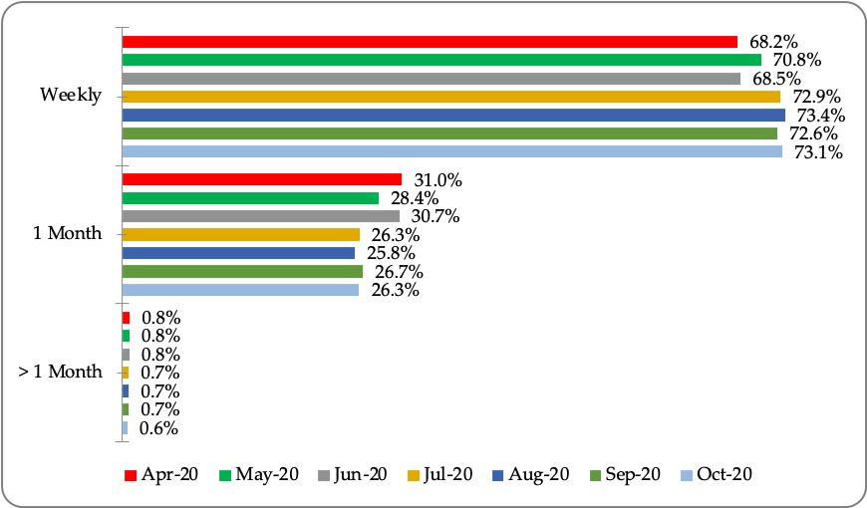

- The turnover of index futures decreased by 0.2 per cent to ₹7.39 lakh crore in October 2020 from ₹7.40 lakh crore in September 2020.
- The turnover of stock futures decreased by 5.8 per cent to ₹14.5 lakh crore in October 2020 from ₹15.4 lakh crore in September 2020.
- The notional turnover in stock options (call and put together) decreased by 1.6 per cent to ₹21.9 lakh crore from ₹22.3 lakh crore during the same period.
- The notional turnover in index options (call and put together) increased by 92.1 per cent to ₹509.0 lakh crore from ₹429.5 lakh crore during the period under consideration.
- As on October 31, 2020, the open interest in equity derivatives at NSE stood at ₹3,06,998.0 crore, a decrease of 17.1 per cent from ₹3, 70,433.5 crore as on September 30, 2020.

Figure 7: Trends of Equity Derivatives Segment at NSE
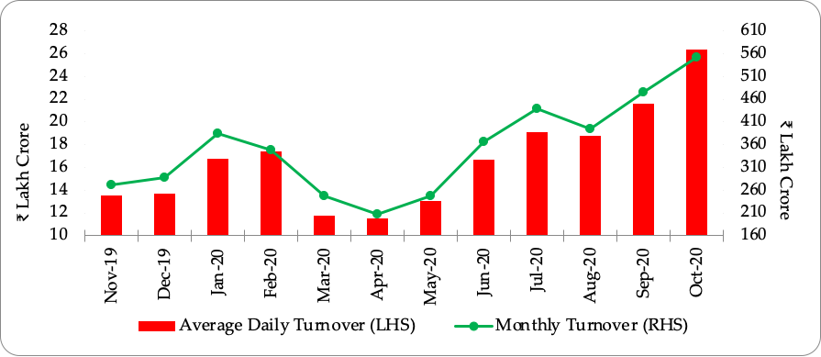

- Currency Derivatives at NSE, BSE and MSEI

- During October 2020, the monthly turnover of currency derivatives in India (NSE, BSE and MSEI together) stood at ₹13, 95,634 crore as compared to ₹15,56,440 crore in September 2020, registering a decrease of 10.3 per cent during the period under consideration.

Figure 8: Trends of Currency Derivatives at NSE, MSEI and BSE
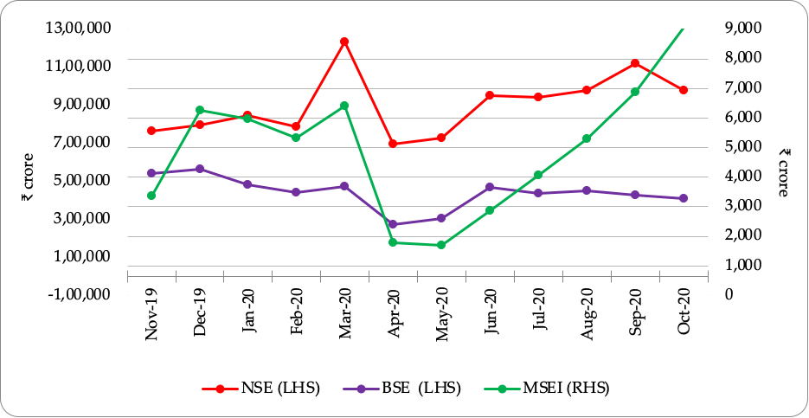

- Interest Rate Derivatives at NSE and BSE

- During October 2020, the monthly turnover of interest rate derivatives (futures and options) at NSE decreased by 25.1 per cent to ₹5,969.4 crore from ₹7,968.2 crore in September 2020. There was no trading activity in its interest rate options segment in October 2020.
- NSE had launched interest rate options during December 2019. The notional turnover of interest rate options stood at ₹2.1 crore during September 2020 and has been on a steep decline since April 2020, when the notional turnover was ₹311.2 crore. The highest notional turnover, since launch, was in March 2020 with ₹4,003.4 crore.
- The monthly turnover of interest rate futures at BSE increased by 215.0 per cent from ₹618.8 crore to ₹ 1,949.4 crore during the same period.

Figure 9: Trends of Interest Rate Futures at NSE and BSE
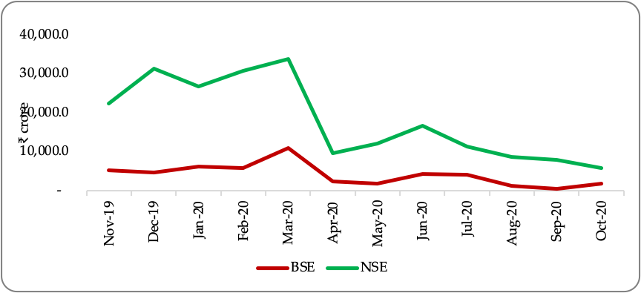

- Trading in Corporate Debt Market

- During October 2020, BSE registered 5,019 trades of corporate debt with traded value of ₹42,448 crore, as compared to 5,695 trades of corporate debt with a traded value of ₹50,694 crore in the previous month.
- At NSE, 5,332 trades were recorded with a traded value of ₹88,404 crore in October 2020 as compared to 5,864 trades with a traded value of ₹90,783crore in September 2020.

Figure 10: Trends in Reported Turnover of Corporate Bonds

- Trends in Institutional Investments

- Trends in Fund Mobilisation/Transactions by Mutual Funds

- As on October 31, 2020, there were a total of 1,742 mutual fund schemes in the market, of which 992 were open-ended schemes, 727 were close-ended schemes and 23 were interval schemes.
- The mutual fund industry saw a net inflow of ₹98,576.0 crore in October 2020; the net outflow during September 2020 was ₹52,091.2 crore.
- The funds mobilised by open-ended schemes during October 2020 was ₹6,43,237.5 crore against redemption/repurchase of ₹5,39,036.3 crore, resulting in a net inflow of ₹1,04,201.1 crore from open-ended schemes. Of the total funds mobilised by the open-ended schemes during the month under consideration, ₹6,08,949.1 crore was mobilised through income/debt oriented schemes, ₹17,514.0 crore through growth/equity oriented schemes, ₹8,056.4 crore through hybrid schemes, ₹199.9 crore through solution oriented schemes and ₹8,518.0 crore through other schemes.
- During October 2020, close-ended schemes worth ₹ 5,623.7 crore were matured/ repurchased. Also, interval schemes worth ₹38.4 crore were matured/redeemed during the period.
- The net assets under management of mutual funds stood at ₹28.2 lakh crore at the end of October 2020, up from ₹26.8 lakh crore at the end of September 2020.
- In the secondary market transactions, during October 2020, mutual funds liquidated ₹14,344 crore from equity schemes and deployed ₹30,996 crore in debt schemes.

Figure 11: Trends in Mutual Funds Transactions in Secondary Market

- Trends in Investments by the Foreign Portfolio Investors (FPIs)

- During October 2020, FPIs invested ₹19,541 crore in the equity segment, as compared to withdrawal of ₹7,783 crore during September 2020. The net investment by FPIs in debt securities declined during October 2020 to ₹ 2,492 crore from ₹ 4,364 crore during September 2020. There was withdrawal of ₹207 crore from hybrid securities during October 2020 against an investment of ₹2,222 crore during the previous month. Thus, October 2020 witnessed net investment of ₹21,826 crore by the FPIs, against net withdrawal of ₹1,197 crore during September 2020.
- The assets of the FPIs in India, as reported by the custodians, at the end of October 2020 were ₹34,36,258 crore, out of which the notional value of offshore derivative instruments (ODIs) (including ODIs on derivatives) was ₹ 78,686 crore which is 2.3 per cent of total assets of FPIs.

Figure 12: Trends in FPIs’ Investments

- Trends in Portfolio Management Services (PMS)

- As on September 30, 2020, AUM of the portfolio management industry stood at ₹19.0 lakh crore. Of the total AUM, funds from EPFO/PFs account for ₹14.3 lakh crore.
- As for number of clients in PMS industry at the end of September 2020, discretionary services category had 1,46,813 clients, followed by non-discretionary category with 8,722 clients and advisory category with 2,410 clients.

- Trends in Substantial Acquisition of Shares and Takeovers

- During October 2020, six open offers with offer value of ₹480.5 crore were made to shareholders under SEBI (Substantial Acquisition of Shares and Takeover) Regulations, 2011 (SAST Regulations). Six offers with offer value of ₹3,010.4 crore were made in the month of September 2020.

Figure 13: Details of Open Offers made under the SEBI (SAST) Regulations

- Commodity Derivatives Markets

- Market Trends

- During October 2020, MCX iCOMDEX composite index, witnessed anincrease of 1.6 per cent (M-o-M) driven by increase in futures prices of base metals (except lead), bullion contracts and agri. contracts of cotton and crude palm oil of agri. segment. On Y-o-Y basis, MCX iCOMDEX composite index decreased by 4.6 per cent.
- During the month, MCX iCOMDEX crude oil index decreased by 10.8 per cent on account of decrease in futures price of crude oil by 10.0 per cent. MCX iCOMDEX base metal index increased by 5.5 per cent due to increase in futures price of all the base metals except lead. MCX iCOMDEX bullion index increased by 0.9 per cent due to increase in futures prices of gold and silver by 0.6 per cent and 1.6 per cent respectively.In the agri. segment, while futures prices of cotton and crude palm oil contracts increased by 5.9 per cent and 7.6 per cent respectively that of cardamom and mentha oil contracts decreased by 6.5 per cent and 1.3 per cent respectively.
- NKrishi index increased by 3.9 per cent (M-o-M) as futures prices of eight out of 10 constituent commodities of the index viz. guarseed, turmeric, RM seed, refined soy oil, cottonseed oilcake, jeera, barley and castorseed witnessed uptrend. On Y-o-Y basis NKrishi index increased by 6.7 per cent.
- Monthly trends in MCX iCOMDEX composite Index and NKrishi Index are provided in Table 64.

Figure 14: Movement of Commodity Derivatives Market Indices during October 2020
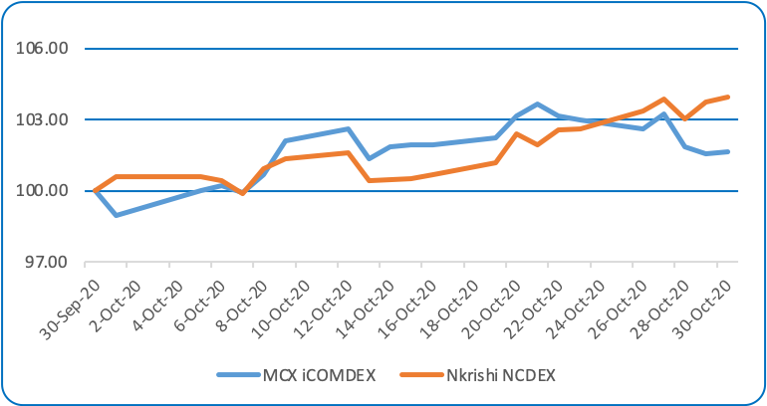
Source: MCX and NCDEX

Table 4: Snapshot of Indian Commodity Derivative Markets
Items | 2019-20 | Sep- 2020 | Oct -2020 | Percentage variation  M-o-M
- Indices
Nkrishi | 3,180 | 3,615 | 3,758 | 3.9
MCX iCOMDEX | 8,256 | 9,714 | 9,874 | 1.6
- Turnover (₹crore)
All-India | 92,24,839 | 8,67,747 | 7,99,498 | -7.9
MCX, of which | 86,89,518 | 7,78,831 | 7,08,681 | -9.0
Futures | 83,97,775 | 7,52,804 | 6,98,765 | -7.2
Options | 2,91,743 | 26,027 | 9,916 | -61.9
NCDEX, of which | 4,42,009 | 28,599 | 32,561 | 13.9
Futures | 4,41,967 | 28,598 | 35,557 | 13.8
Options | 42.2 | 1.1 | 3.6 | 238.3
ICEX (Futures) | 40,511 | 0.2 | 0.1 | -31.6
BSE, of which | 46,439 | 58,517 | 56,385 | -3.6
Futures | 46,439 | 185 | 248 | 33.8
Options | - | 58,331 | 56,137 | -3.8
NSE, of which | 6,362 | 1,800 | 1,871 | 3.9
Futures | 6,362 | 66 | 14 | -78.4
Options | - | 1,734 | 1,857 | 7.0
Source: NCDEX, MCX, ICEX, BSE and NSE.

- Turnover
- During October 2020, pan- India turnover of the commodity derivatives decreased by 7.9 per cent to ₹7,99,498 crore driven by fall in turnover at MCX, ICEX and BSE. However, turnover at NCDEX and NSE have increased during the month. The agricultural segment contributed 5.0 per cent to the total turnover, while non-agricultural segment accounted for 95.0 per cent.
- The total turnover at MCX decreased by 9.0 per cent to ₹7,08,681crore during October 2020 driven by fall in traded value of bullion and metal futures by 16.5 per cent and 0.5 per cent respectively. However, turnover in energy and agri. futures increased by 9.1 per cent and 3.8 per cent respectively. The notional turnover of options segment at MCX decreased significantly by 61.9 per cent during the month driven by decline in turnover at all segments. The options contracts contributed 1.4 per cent to the total turnover at MCX. The total turnover in iCOMDEX bullion futures indices decreased by 5.3 per cent to ₹ 4,909 crore during the month.
- MCX has launched futures trading in Metaldex index on 19th October, 2020 and recorded a total turnover of ₹ 659 crore during the month.
- During the month, the total turnover at NCDEX increased by 13.9 per cent to ₹ 32,561 crore, due to increase in traded volume and value of ten out of total 17 traded commodities. Turnover in Agridex futures indices increased to ₹24 crore during Oct. 2020.
- In October 2020, turnover at ICEX decreased by 31.6 per cent to ₹0.1 crore recorded by gems and stones futures.
- The total turnover at BSE decreased by 3.6 per cent to ₹ 56,385 crore driven by the decline in turnover in bullion options by 3.8 per cent. In the futures segment bullion and agri. contracts recorded a total turnover of ₹11 crore and ₹ 237 crore respectively.
- The total turnover at NSE increased by 3.9 per cent to ₹1,871 crore during the month on account of increase in turnover of bullion options by 7.0 per cent.
- The turnover of agricultural and non-agricultural commodities at exchanges is shown in Figures 15, 16 and 17 and the details are given in Tables 65 to 69.

Figure 15: Trends in Turnover of Agricultural Commodity Derivatives
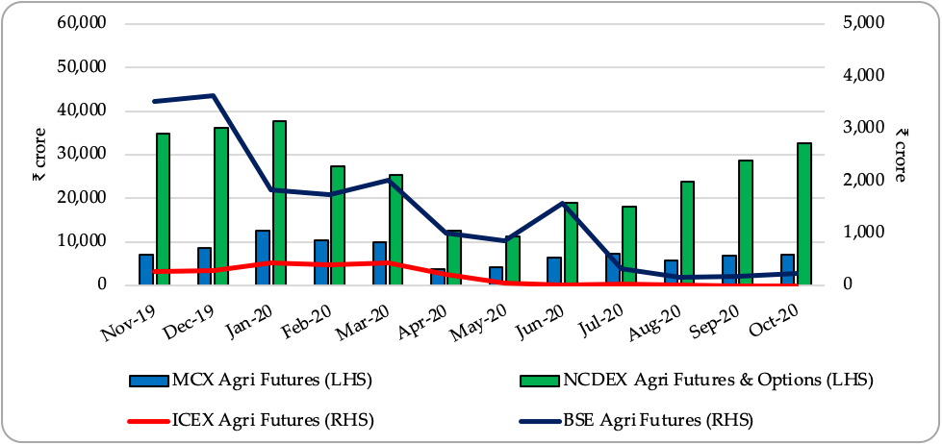
Source: MCX, NCDEX, BSE & ICEX

Figure 16: Trends in Turnover of Non-Agricultural Futures Commodity Derivatives contracts
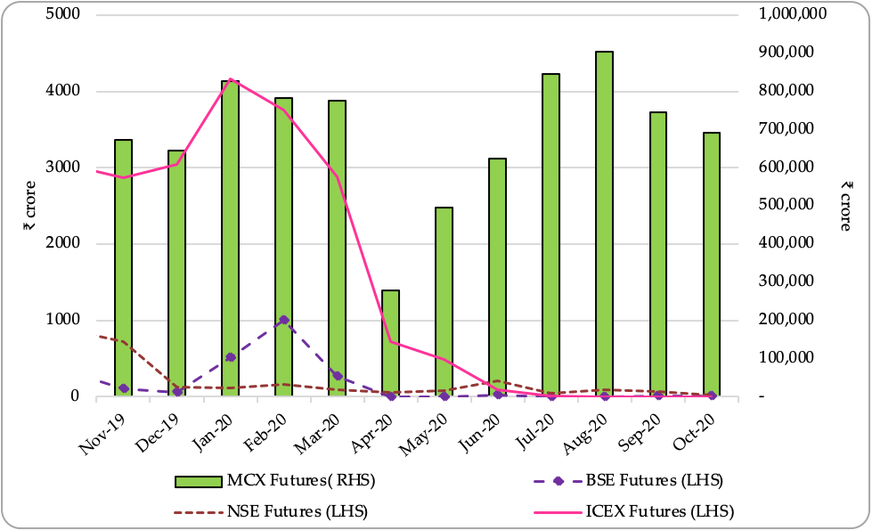
Source: MCX, ICEX, BSE & NSE.

Figure 17: Trends in Turnover of Non-Agricultural Options Commodity Derivatives contracts
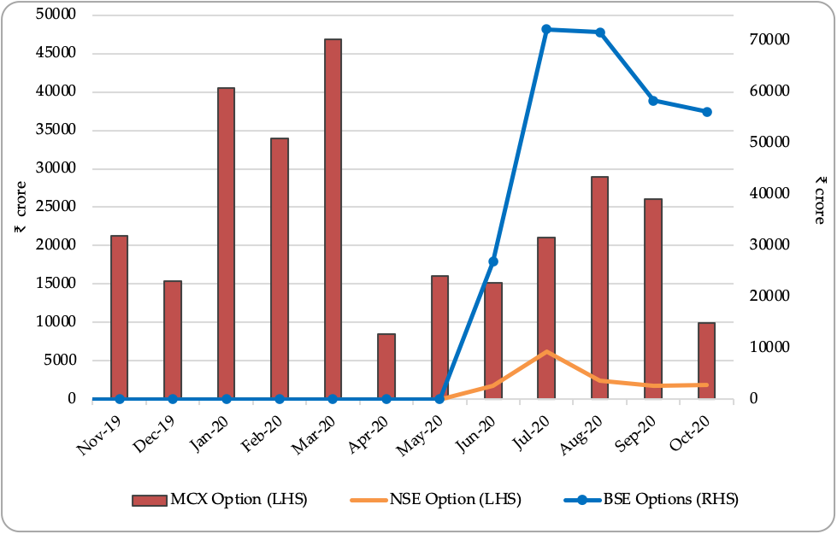
Source: MCX, BSE & NSE.

OVERVIEW OF THE GLOBAL FINANCIAL MARKETS

- The ongoing coronavirus outbreak continued to cause human and economic distress around the globe even in October 2020. The month of October saw resurgence of fresh COVID-19 infections in USA (1.9 million compared to 1.3 million in previous month), France (0.8 million new cases in October vs 0.3 million in previous month), while that in India and Brazil the impact was moderated (1.9 million compared to 2.6 million in previous month and 0.7 million compared to 0.9 million in previous month respectively), according to data published by worldometers.info. The major commodities registered a negative return during October 2020. The crude oil prices fell sharply on concerns over weaker demand related to the coronavirus.

- European countries like France, Germany and UK re-introduced nationwide lockdowns, as the second COVID-19 wave emerged in Europe. France declared a second national lockdown, starting October 30, 2020, wherein people would be allowed to leave home for essential work or medical reasons. Non-essential businesses, such as restaurants and bars, will close, but schools and factories will remain open. Germany too declared an emergency lockdown between November 2 to November 30, less severe but includes the closure of restaurants, gyms and theatres. The UK too re-introduced lockdown from November 05 to December 02, 2020, wherein pubs, restaurants and non-essential shops will remain closed.

- The financial markets worldwide remained on the tenterhooks in October, as it awaited results of the US Presidential and Congressional elections, held on November 03, 2020. The democratic party candidate, Joe Biden, emerged as the frontrunner for the US presidency, while US senate headed for the split senate. The market perceived that the split outcome would reduce the chances for a big fiscal stimulus package from Congress in the new year, even as the COVID-19 pandemic continues to threaten the economy.

- Meanwhile, the International Monetary Fund (IMF), in its World Economic Outlook, October 2020 issue, revised the world economic growth upward for 2020 to -4.4 per cent from -4.9 per cent forecast made in June 2020. This is due to better than expected growth in advanced economies and China during the second quarter of the year and signs of a more rapid recovery in the third quarter. The IMF’s projection assumes that social distancing due to the coronavirus pandemic will continue into 2021, and that local transmission will fall everywhere by the end of 2022.

- The world economic activity resumes its growth in month of October 2020, after a good recovery in the past few months. The JPMorgan Global Composite Purchasing Managers’ Index (PMI), compiled by IHS Markit, increased to 53.30 in October 2020 from 52.10 in September 2020. A reading of PMI above 50 means growth or expansion in economic activity.

- Most of the global equity markets, with the exception of India, China and Hong Kong, registered negative returns in October 2020, for the second consecutive month, as markets awaited the US election results and on fears of fresh lockdowns. The Dow Jones Industrial Average of USA declined by 4.6 per cent in October 2020 over previous month. The S&P 500 index decreased by 2.8 per cent, and the tech heavy NASDAQ Composite declined by 2.3 per cent in October 2020 over previous month.

- The emerging equity markets outperformed advanced markets in October 2020. MSCI Emerging Market (EM) index increased by 2.0 per cent in October 2020 over the previous month, while MSCI World index was down by 3.1 per cent during same period.

- The volatility returned to the equity markets during end of October 2020, as the market awaited the results of the US Presidential election on November 03, 2020. The CBOE VIX index increased sharply to 38.0 on October 30, 2020, from 26.4 on September 30, 2020.

- The bond markets witnessed mixed trends during October 2020. While the US 10-year government bond yield increased by 19 bps to 0.87 per cent during October 2020, the 10-year Eurozone Central Government Bond yield declined by 6 bps to -0.14 per cent. The 10-year government bond yield of India fell by 13 bps to 5.88 per cent on October 30, 2020 from 6.01 per cent on September 30, 2020.

- The crude oil prices decreased by USD 4.4 per barrel (or by 11.0 per cent) to USD 35.8 per barrel in October 2020. Gold prices too decreased by USD 7.0 per ounce (or by 0.4 per cent) to USD 1,878.8 on October 30, 2020, after touching high of USD 2,089.2 during September 2020.

- The US economy expanded by 7.4 per cent Q-o-Q (33.1 per cent Q-o-Q in annualised terms) in the Q3 of 2020, compared to contraction of 9.0 per cent Q-o-Q in the Q2 of 2020 (or 31.4 per cent contraction Q-o-Q in annualised terms). It is the biggest expansion ever, following a steep fall in Q2 of 2020, as the economy rebounds from coronavirus pandemic. The US unemployment rate fell to 6.9 per cent in October 2020, from 7.9 per cent in September 2020, reflecting continued resumption of economic activity disrupted due to COVID-19 pandemic. The US PMI data also indicate rising economic activity. The IHS Market’s US Composite PMI rose to 56.3 in October 2020 from 54.4 in September 2020.

- The UK economy grew by 15.5 per cent Q-o-Q in Q2 of 2020 (-8.4 per cent Y-o-Y), the largest-ever sequential expansion in GDP since 1955, as the economy recovers from COVID-19 induced lockdown. In the previous quarter GDP had contracted by the record 19.8 per cent Q-o-Q. The economic activity remained on the recovery path as Markit UK composite PMI for October 2020 dropped to 52.1, compared to 52.9 in previous month. However, with a second lockdown introduced in UK until at least December 2 amid a resurgence in coronavirus cases, the recovery is expected to lose steam in the final three months of the year.

- The Eurozone economy expanded by 12.7 per cent Q-o-Q (-4.3 per cent Y-o-Y) in Q3 of 2020, after a contraction of 11.8 per cent in Q2 of 2020. All major economies in the Eurozone posted record increases in GDP. The GDP of France rose by 18.2 percent in Q3 of 2020 compared to -13.7 percent in Q2 of 2020, Spain (16.7 percent vs -17.8 percent), Italy (16.1 percent vs -13.0 percent), and Germany (8.2 percent vs -9.8 percent). However, the economic activity in the Eurozone declined slightly in October 2020. The IHS Markit Eurozone composite PMI for October 2020 fell to 50.0, compared to 50.4 in the previous month. The IMF expects Eurozone output to contract by 10.2 per cent in 2020.

- In a widely anticipated move, the Federal Open Market Committee (FOMC), in its November meeting, left the interest rate unchanged at zero to 0.25 per cent to support the U.S. economy. Last month, the US Federal Reserve (Fed) had signaled that interest rates would remain near zero at least through 2023. According to Fed chair, Jerome Powell, the economic recovery in US has progressed more quickly than generally expected, however overall activity still remained below the level before start of the pandemic. The IMF upwardly revised USA growth expectations for 2020 to -4.3 per cent from earlier forecast of -8.0 per cent.

- The European Central Bank (ECB), in its October meeting, decided to keep interest rates (0.0 per cent) and emergency coronavirus stimulus asset purchase program (Euro 1.35 trillion) unchanged, while it monitors the economic strength of the Euro zone. The ECB's Governing Council said it would recalibrate its monetary-policy instruments to respond to the second wave of the COVID-19 pandemic that has forced a number of major economies into lockdown again.

- The CPI inflation and core inflation in the Eurozone remained low at -0.3 per cent and 0.2 per cent, respectively, during September 2020, much below the ECB medium term target range of 2.0 per cent. The ECB said it expected headline inflation to remain negative until early 2021 because of weak demand, but a pick up over medium terms as the impact of COVID-19 vanes.

- In April 2020, the ECB started Pandemic Emergency Purchase Program (PEPP), a more flexible program of government bond purchases. This was further expanded by 600 billion Euros in June 2020, bringing the size of the stimulus program to 1.35 trillion Euros ($ 1.54 trillion) to be deployed until June 2021, or until the ECB believes the crisis is over.

- GDP growth of China rebounded strongly by 4.9 per cent year-on-year in Q3 of 2020, compared to growth rate of 3.2 per cent in Q2 of 2020. According to IMF projections, the Chinese economy is expected to slow down to 1.9 per cent in 2020 before recovering to strong growth of 8.2 per cent in 2021.

- India’s GDP growth contracted sharply by 23.9 per cent Y-o-Y in Q1 of 2020-21, the biggest contraction on record, compared to 3.1 per cent in Q4 of 2019-20. The business activity in construction (-50.3 per cent), hotels and transportation (-47.0 per cent) and manufacturing (-39.3 per cent) sectors recorded the biggest falls. Meanwhile, India GDP forecast by IMF for 2020-21 was revised sharply downwards to -10.3 per cent, compared to its earlier forecast of growth of -4.5. According to IMF projections, the Indian economy is expected to grow by 8.8 per cent in 2021.

- Retail inflation (CPI Inflation) in India spiked to 7.6 per cent in October 2020, the highest since May 2014, compared to 7.3 per cent in the previous month. Index of Industrial Production (IIP) growth recovered to 0.2 percent in September 2020, after registering -7.4 percent growth in the previous month. India’s PMI data indicated strong pick up in the economic activity in the month of October 2020. India’s composite PMI expanded to 58.0 in October 2020 from 54.6 in September 2020. The manufacturing PMI for October surged to 58.9 from 56.8 in September 2020, the highest reading for the indicator since January 2012. The services PMI improved remarkably to 54.1 in October 2020 from 49.8 in previous month.

Market Trends –

Equity Markets (Figures 1-2, Table A1)-
- In the month of October 2020, highest annualized monthly volatility amongst the BRICS countries was observed in Russian Traded (62.1 per cent) followed by Brazil IBOVESPA (40.0 per cent), Nifty 50 (30.2 per cent) and Sensex (29.7 per cent). The lowest annualized volatility among BRICS was observed in South Africa FTSE (17.5 per cent) and Shanghai Composite (20.2 per cent). Among the developed markets, highest annualized volatility was observed in US Nasdaq composite (42.0 per cent) and the lowest was observed at Japan Nikkei (19.9 per cent)).

- In most of the analyzed markets, monthly decline was observed in indices during October 2020. In BRICS nations an increase was observed in India (Nifty 50 (3.5 per cent) and S&P BSE SENSEX (4.1 per cent)) followed by Shanghai Composite (0.2 per cent). The highest monthly decline was observed in Russia Traded (10.7 per cent) followed by South Africa FTSE (4.8 per cent). Among the developed economies, in the month of October 2020, highest indices growth was observed for Hong Kong Hang Seng (2.8 per cent) followed by Taiwan Taiex (0.2 per cent). Monthly decline in growth was observed in Germany DAX (9.4 per cent) followed by UK FTSE (4.9 per cent), US Dow Jones (4.6 per cent) and France CAC 40 (4.4 per cent). Growth for Nasdaq Composite, Singapore STI and Japan Nikkei was -2.3, -1.7 and -0.9 per cent respectively.

Figure 1: Stock Market Trends in Selected Developed Markets

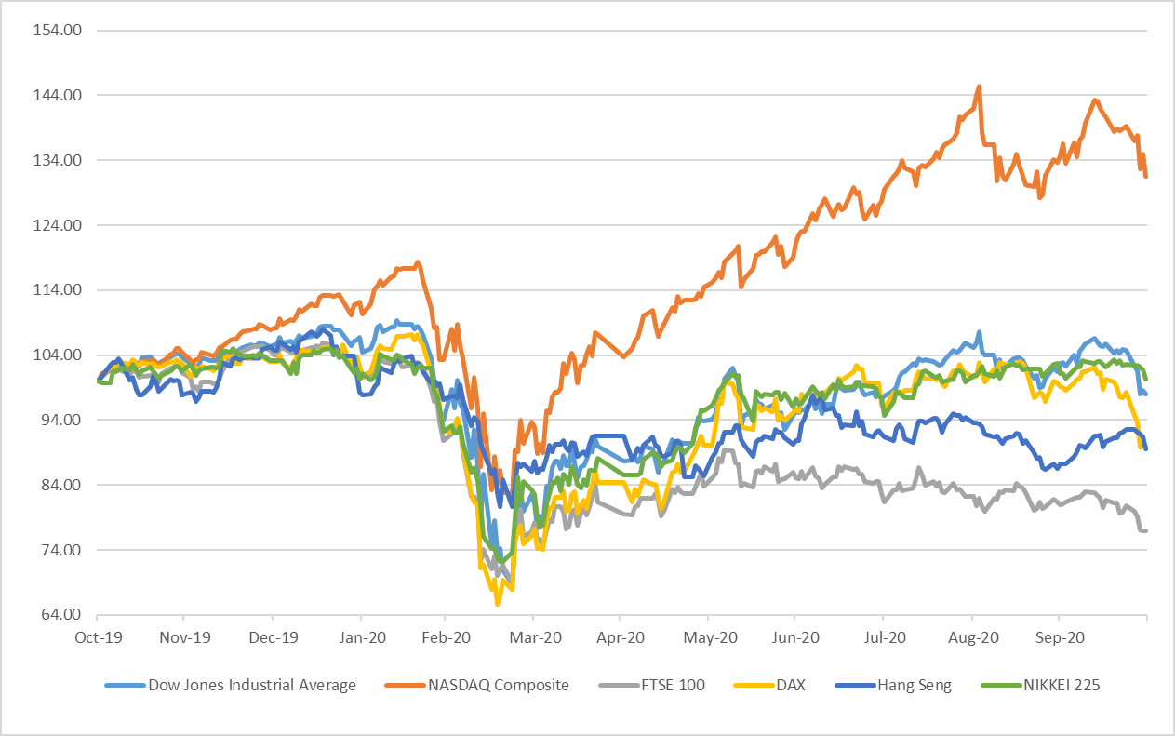

Note: All indices have been normalised to 100 on 31 October 2019.

Source: Bloomberg

Figure 2: Stock Market Trends in Selected Emerging Markets
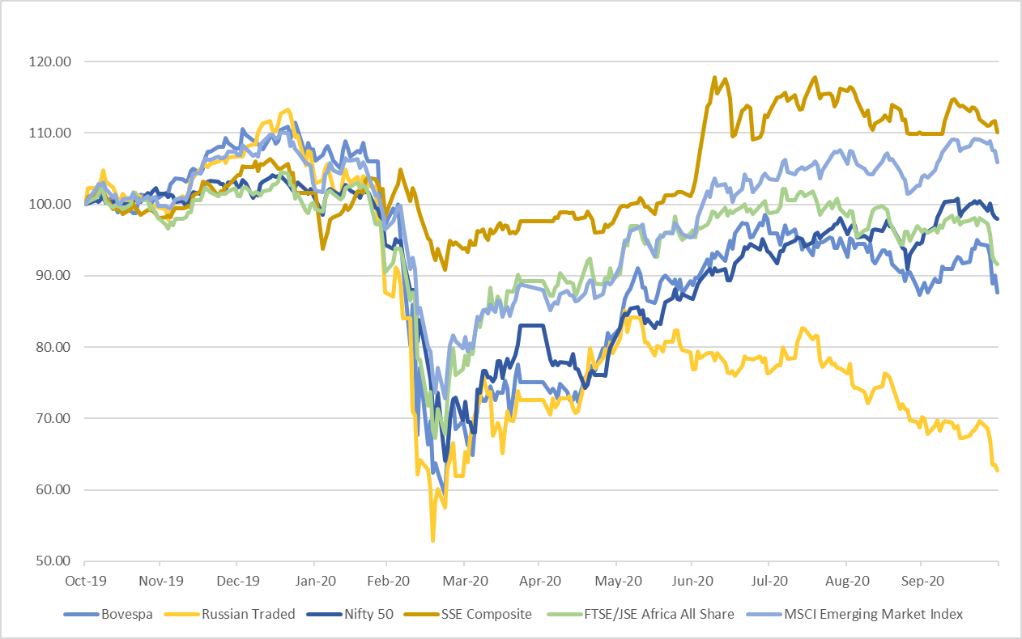

Note: All indices have been normalised to 100 on 31 October 2019.

Source: Bloomberg

BOND Market (Figures 3-4)
- Among the countries analysed, for bond yield, 10-year bond yield showed a positive change for most developed and developing economies (Chart 3 & 4) except for Spain, India, and Russia in October 2020.

Figure 3: Movement of 10-year Government Bond Yields in Developed Nations

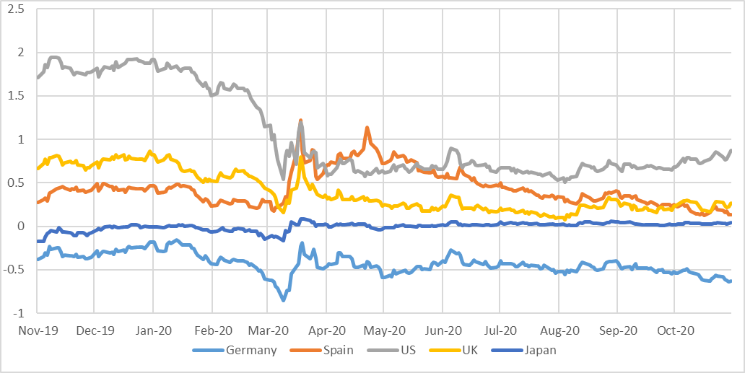

Source: Bloomberg

Figure 4: Movement of 10-year Government Bond Yields in BRIC Nations

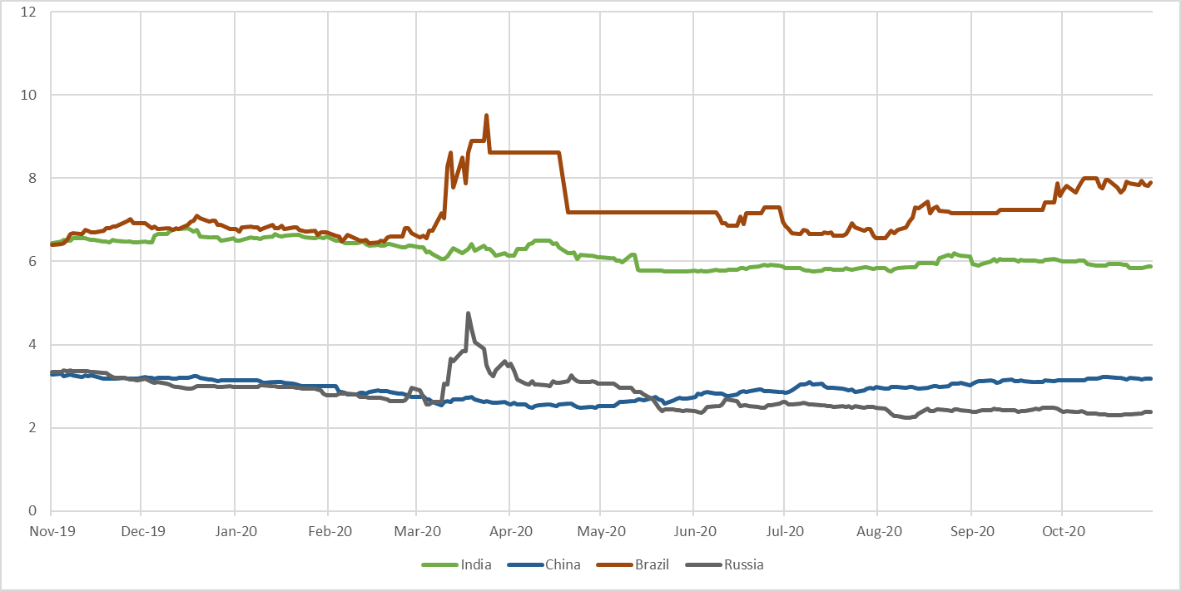

Source: Bloomberg

Fund Mobilisation by Issuance of Equity and Bonds (Table A2) –
- There was a 13.2 per cent increase in the fund mobilization at the selected analyzed exchanges world-wide during September 2020 (at 449,331 million USD) against previous month (at 396,994 million USD). Only 17.7 per cent of the total fund mobilization in September 2020 was in equity and remaining was in debt.
- As per the data available on World Federation of Exchanges (WFE), highest amount mobilized through equities and bonds in September 2020 was at LSE Group (81,004 million USD) followed by Deutsche Boerse AG (61,465 million USD) and NSE (57,159 million USD).
- In September 2020, fund mobilization at LSE Group in equity was, 3,894 million USD were raised through equity and the remaining amount was raised through bonds whereas at Deutsche Boerse AG 376 million USD were raised through equity and the remaining amount was raised through bonds. At NSE 1,420 million USD were raised through equity and the remaining amount was raised through bonds.
- Maximum fund mobilization through equities in September 2020 was at Shanghai Stock Exchange (15,364 million USD) followed by Japan Exchange Group (13,971 million USD).

Market Capitalisation of Major Exchanges (Table A3) –

- Most of the analysed exchanges of selected markets, reflected a decrease in market capitalization in the month of September 2020 as compared to previous month.
- Among the two exchanges which registered increase in market capitalization were Korea Exchange and Japan Exchange Group (2.5 and 1.5 per cent respectively)
- Among the exchanges which lost most of the market capitalization among the analysed ones were Moscow Exchange (-7.3 per cent), B3 - Brasil Bolsa Balcão (-6.3 per cent) and ASX Australian Securities Exchange (-5.9 per cent).

Derivatives (Figures 5-6, Table A4–A8) –

- During September 2020 the highest number of single stock futures contracts traded was at Korea Exchange (109,217,443) followed by Borsa Istanbul (98,250,011). The highest number of single stock options were traded at B3 - Brasil Bolsa Balcão (170,217,968) followed by Nasdaq - US (156,733,224).
- In the same period, highest number of contracts of index futures were traded at B3 - Brasil Bolsa Balcão (282,424,209) followed by CME Group (129,980,200). Among the stock index options, the highest number of contacts were traded at NSE (642,069,544) followed by Cboe Global Markets (55,834,640).
- Highest number of currency futures contracts were traded at Moscow Exchange (94,839,309) followed by B3 - Brasil Bolsa Balcão (77,568,946). The highest number of currency options were traded at NSE (78,212,322) followed by Moscow Exchange (32,582,479).
- In September 2020, the highest number of interest rate futures and interest rate options contracts were traded at CME Group (83,275,476 and 18,667,966 respectively) followed by B3 - Brasil Bolsa Balcão (51,947,175 and 13,498,350 respectively).
- The highest number of commodity futures contracts were traded at Dalian Commodity Exchange (217,136,104) followed by Shanghai Futures Exchange (204,520,697) in September 2020. Among the commodity options the highest number of contracts were traded at CME Group (12,851,369) followed by Dalian Commodity Exchange (5,925,118) during the same period.
- In October 2020, Won and Rand were most appreciating currencies against dollar among the analysed currencies. Ruble and Real were most depreciating currencies.

US Treasury Securities (Table A9)

- At the end of September 2020, Japan was the biggest foreign holder of US Treasury Securities with 18.0 per cent followed by China with 15.0 per cent. The total foreign holding of US Treasury Securities as on September 2020 was USD 7,071 billion. The holdings of US Treasury Securities by India slightly increased to 3.0 per cent at the end of September 2020 from 2.8 per cent a month earlier.

Figure 5: Movement of the Major Currencies against USD
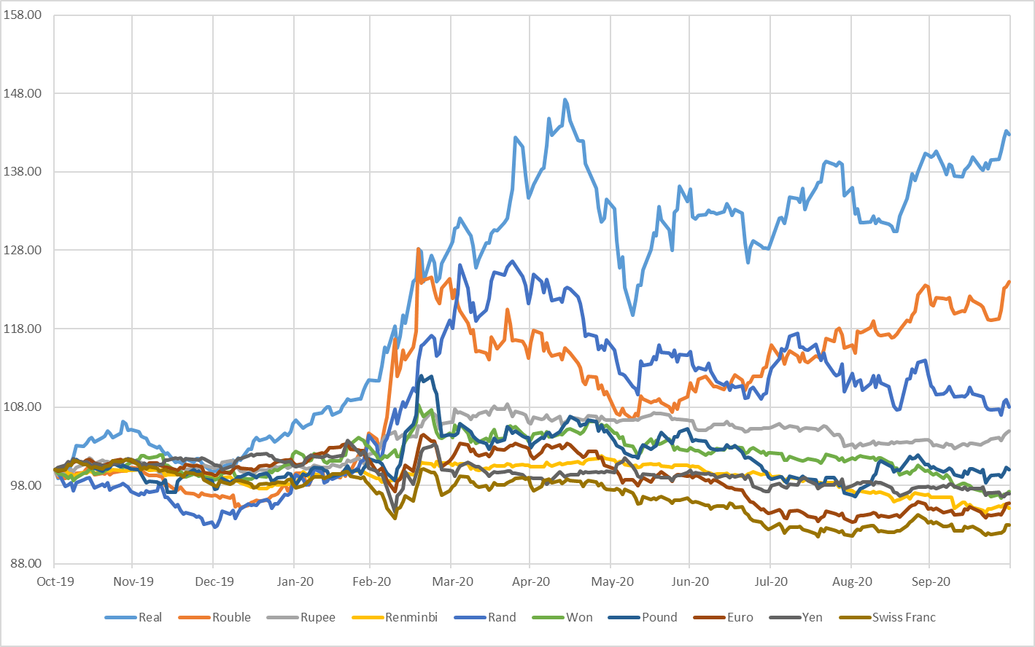
Note: All indices have been normalised to 100 on 31 October 2019.

Source: Bloomberg

Figure 6: Movement of the US Dollar Index and MSCI EM Currency Index

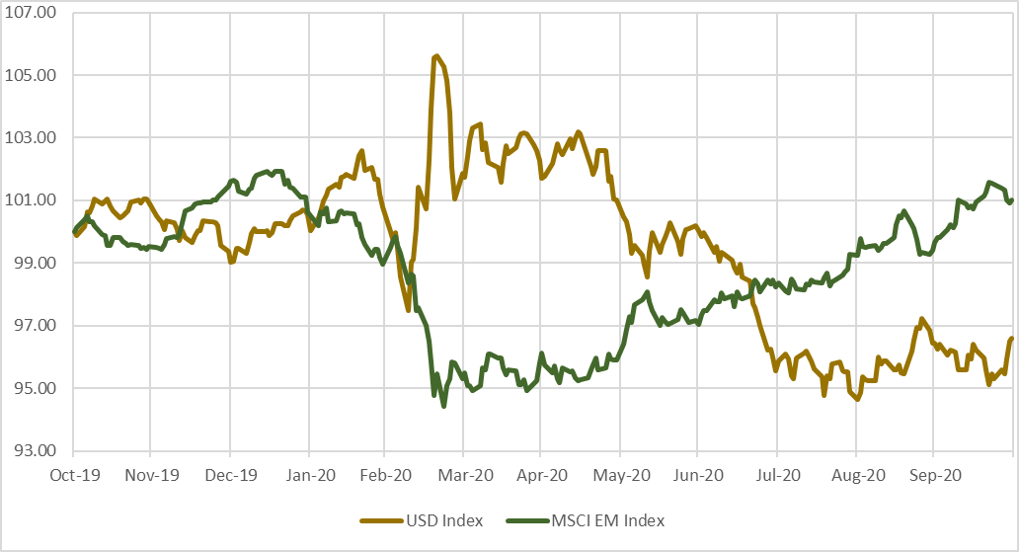
Note:
- All indices have been normalised to 100 on 31 October 2019.
- The U.S. Dollar Index is an index of the value of the United States dollar relative to a basket of foreign currencies. The Index goes up when the U.S. dollar gains value compared to other currencies. The index is maintained and published by Intercontinental Exchange. It is a weighted geometric mean of the dollar's value relative to following select currencies: Euro, Japanese yen, Pound sterling, Canadian dollar, Swedish krona, Swiss franc.
- The MSCI Emerging Markets (EM) Currency Index tracks the performance of twenty-five emerging-market currencies relative to the US Dollar.

Source: Bloomberg

Table A1: Performance of Stock Indices
Country | Name of the Index | Closing Value as on | Closing Value before |  |  |  | Monthly Volatility (Annualised) | P/E Ratio
 |  | 31-Oct -2020 | 1-Month | 3-Month | 6-Month | 1-Year
BRICS Nations
Brazil | BRAZIL IBOVESPA | 93952.4 | 94603.4 | 102912.2 | 80505.9 | 107219.8 | 40.0 | 42.1
Russia | RUSSIAN TRADED | 1329.5 | 1488.1 | 1618.1 | 1538.1 | 2118.2 | 62.1 | 10.0
India | Nifty 50 | 11642.4 | 11247.6 | 11073.5 | 9859.9 | 11877.5 | 30.2 | 31.9
India | S&P BSE SENSEX | 39614.1 | 38067.9 | 37606.9 | 33717.6 | 40129.1 | 29.7 | 27.6
China | SHANGHAI SE COMPOSITE | 3224.5 | 3218.1 | 3310.0 | 2860.1 | 2929.1 | 20.2 | 14.5
South Africa | FTSE/JSE AFRICA ALL SHR | 51684.7 | 54265.0 | 55721.8 | 50336.7 | 56425.1 | 17.5 | 12.4
Developed Markets
USA | NASDAQ COMPOSITE | 10911.6 | 11167.5 | 10745.3 | 8889.6 | 8292.4 | 42.0 | 35.4
USA | DOW JONES INDUS. AVG | 26501.6 | 27781.7 | 26428.3 | 24345.7 | 27046.2 | 35.1 | 22.0
France | CAC 40 | 4594.2 | 4803.4 | 4783.7 | 4572.2 | 5729.9 | 24.1 | 23.7
Germany | DAX | 11556.5 | 12760.7 | 12313.4 | 10861.6 | 12866.8 | 25.4 | 17.2
UK | FTSE 100 | 5577.3 | 5866.1 | 5897.8 | 5901.2 | 7248.4 | 23.7 | 18.3
Hong Kong | HANG SENG | 24107.4 | 23459.1 | 24595.4 | 24643.6 | 26906.7 | 32.0 | 12.6
South Korea | KOSPI | 2267.2 | 2327.9 | 2249.4 | 1947.6 | 2083.5 | 32.6 | 36.8
Japan | NIKKEI 225 | 22977.1 | 23185.1 | 21710.0 | 20193.7 | 22927.0 | 19.9 | 34.7
Singapore | STRAITS TIMES STI | 2423.8 | 2466.6 | 2529.8 | 2624.2 | 3229.9 | 20.5 | 16.4
Taiwan | TAIWAN TAIEX | 12546.3 | 12515.6 | 12664.8 | 10992.1 | 11358.7 | 22.5 | 20.4
Note: P/E Ratios as on the last trading day. Trailing PE ratio has been used from Bloomberg for all Indices apart from Sensex, Nifty 50, Kospi, Nikkei and Taiwan Taiex. Forward PE from Bloomberg was used for Kospi, Nikkei and Taiwan Taiex. Data for Sensex and Nifty was taken from respective exchange website. Data is as on 02 December 2020
Source: Bloomberg, BSE and National Stock Exchange

Table A2: Fund Mobilisation by Issuance of Equity and Bond in Major Exchanges (USD million)
Month | Aug-20 |  |  | Sep-20
Exchange Name | Bond | Equity | Total | Bond | Equity | Total
B3 - Brasil Bolsa Balcão | 0 | 0 | 0 | NA | 0 | 0
Nasdaq - US | NA | 0 | 0 | NA | 0 | 0
NYSE | NA | 18,437 | 18,437 | NA | 12,938 | 12,938
ASX Australian Securities Exchange | NA | 3,342 | 3,342 | NA | 3,906 | 3,906
Hong Kong Exchanges and Clearing | 17,311 | 7,666 | 24,976 | 17,027 | 13,596 | 30,622
Japan Exchange Group | 1,876 | 3,571 | 5,447 | 1,460 | 13,971 | 15,432
Korea Exchange | 51,808 | 0 | 51,808 | 51,446 | 0 | 51,446
National Stock Exchange of India | 55,347 | 6,617 | 61,964 | 55,739 | 1,420 | 57,159
Shanghai Stock Exchange | NA | 13,796 | 13,796 | NA | 15,364 | 15,364
Shenzhen Stock Exchange | 28,672 | 12,186 | 40,858 | 26,811 | 6,995 | 33,806
Singapore Exchange | 16,068 | 37 | 16,105 | 28,323 | 1,538 | 29,861
BME Spanish Exchanges | 21,298 | 8,044 | 29,343 | 24,721 | 14 | 24,734
Deutsche Boerse AG | 38,735 | 0 | 38,735 | 61,089 | 376 | 61,465
Euronext | 776 | 2,134 | 2,909 | NA | 3,692 | 3,692
Johannesburg Stock Exchange | 3,811 | 385 | 4,197 | 4,166 | 1,666 | 5,833
LSE Group | 63,332 | 277 | 63,609 | 77,110 | 3,894 | 81,004
Moscow Exchange | 21,467 | 0 | 21,467 | 22,050 | 19 | 22,069
Grand Total | 320,501 | 76,493 | 396,994 | 369,942 | 79,389 | 449,331
Note: For Funds mobilised through issuance of bonds, data may differ due to different reporting rules & calculation methods. Fund mobilisation data for equities are (i) excluding investment funds and (ii) including Alternative and SME Markets except the following exceptions:
- Australian Securities Exchange: including investment funds
- BME: Including investment companies listed (open-end investment companies).
- Euronext: includes Belgium, England, France, Netherlands and Portugal
- Korea Exchange: including Kosdaq market data
- LSE Group: includes London Stock Exchange and BorsaItaliana
- Nasdaq Nordic Exchanges include Copenhagen, Helsinki, Iceland, Stockholm, Tallinn, Riga and Vilnius Stock Exchanges
- NSE India: including “Emerge” market data

NA = Not Available
Source: World Federation of Exchanges

Table A3: Domestic Market Capitalisation of Major Exchanges (USD Billion)

Exchnage | Aug-20 | Sep-20 | % Change MoM
Nasdaq - US | 17,251.3 | 16,439.0 | -4.7%
NYSE | 23,201.8 | 22,799.5 | -1.7%
LSE Group | 3,470.4 | 3,301.6 | -4.9%
Deutsche Boerse AG | NA | 2,104.5 | NA
BME Spanish Exchanges | 651.9 | 619.9 | -4.9%
Japan Exchange Group | 5,983.4 | 6,075.5 | 1.5%
Singapore Exchange | 599.6 | 583.7 | -2.7%
Hong Kong Exchanges and Clearing | 5,515.7 | 5,372.7 | -2.6%
Korea Exchange | 1,600.5 | 1,640.7 | 2.5%
ASX Australian Securities Exchange | 1,480.0 | 1,392.5 | -5.9%
B3 - Brasil Bolsa Balcão | 763.5 | 715.1 | -6.3%
Moscow Exchange | 628.3 | 582.6 | -7.3%
National Stock Exchange of India | 2,079.6 | 2,080.3 | 0.0%
Shanghai Stock Exchange | 6,327.1 | 6,092.3 | -3.7%
Shenzhen Stock Exchange | 4,763.4 | 4,534.8 | -4.8%
Johannesburg Stock Exchange | 866.1 | 841.8 | -2.8%

NA: Not Available

Source: World Federation of Exchanges

Note:
- The figures provided in some versions of SEBI Bulletin are sourced from Bloomberg which provides country wise market capitalization data (estimated internally by Bloomberg).
- The figures provided World Federation of Exchanges are more detailed and are provided by respective member exchanges.
- Data for this table needs to be read in Billion for Nov-2019, Jan-2020 to Oct-2020
- As per the data available as on 19 Nov 2020.

Table A4: Stock Futures and Stock Options Traded in Major Exchanges

Notional Turnover in (USD million)
Exchange | Sep-20
 | Single Stock Futures |  |  | Single Stock Options
 | Number of | Notional | Open | Number of | Notional | Open
 | Contracts Traded | Turnover | Interest | Contracts Traded | Turnover | Interest
B3 - Brasil Bolsa Balcão | 39,217,700 | 162 | 24,106,300 | 170,217,968 | 90,767 | 44,130,604
Bolsa de Valores de Colombia | 23,058 | 24 | 9,282 | 0 | 0 | 0
Bolsa Mexicana de Valores | 950 | 0 | 700 | 15,000 | 1 | 28,000
Bolsa y Mercados Argentinos | NA | NA | NA | NA | NA | NA
Cboe Global Markets | NA | NA | NA | 110,354,228 | NA | 226,779,202
Nasdaq - US | NA | NA | NA | 156,733,224 | NA | NA
MIAX Exchange Group | NA | NA | NA | 55,610,788 | 1,065,896 | NA
ASX Australian Securities Exchange | 195,898 | 225 | 401,258 | 4,740,574 | 9,716 | 6,171,761
Hong Kong Exchanges and Clearing | 97,454 | 568 | 16,262 | 10,126,369 | 45,083 | 8,611,285
Japan Exchange Group | NA | NA | NA | 4,999 | NA | 40,608
Korea Exchange | 109,217,443 | 69,425 | 5,996,899 | 102,022 | NA | 9,909
National Stock Exchange of India | 20,622,408 | 208,706 | 1,422,238 | 27,039,033 | 302,993 | 578,006
Singapore Exchange | 155,035 | NA | 33,609 | NA | NA | NA
Taiwan Futures Exchange | 2,179,460 | 18,932 | 188,713 | 8,926 | 60 | 4,190
Thailand Futures Exchange | 2,580,200 | NA | 1,220,429 | NA | NA | NA
Athens Stock Exchange | 1,041,338 | 176 | 282,747 | 1,413 | 1 | 1,276
BME Spanish Exchanges | 719,796 | 202 | 1,265,314 | 1,226,275 | 1,124 | 8,433,119
Borsa Istanbul | 98,250,011 | 7,891 | 7,667,382 | 346,199 | 31 | 343,438
Budapest Stock Exchange | 8,557 | 47 | 5,442 | NA | NA | NA
Deutsche Boerse AG | 6,214,179 | 29,255 | 4,958,433 | 14,056,749 | 66,308 | 60,356,483
Euronext | NA | NA | NA | NA | NA | NA
Moscow Exchange | 15,240,225 | 4,104 | 1,339,972 | 126,761 | 33 | 94,682
Nasdaq Nordic and Baltics | 76,148 | 69 | 127,505 | 1,622,501 | 2,790 | 3,240,027
Tehran Stock Exchange | 0 | 0 | 0 | 1,445,364 | 15 | NA
Tel-Aviv Stock Exchange | NA | NA | NA | 87,551 | 280 | 50,613
Warsaw Stock Exchange | 213,716 | 329 | 33,910 | NA | NA | NA
Dubai Gold and Commodities Exchange | 10,448 | 24 | 689 | NA | NA | NA
Grand Total | 296,064,024 | 340,138 | 49,077,084 | 553,865,944 | 1,585,098 | 358,873,203
NA: Not Available
Source: World Federation of Exchanges

Table A5: Index Futures and Index Options Traded in Major Exchanges
Notional Turnover in (USD million)
Exchange | Sep-20
 | Stock Index Futures |  |  | Stock Index Options
 | Number of  Contracts Traded | Notional  Turnover | Open  Interest | Number of  Contracts Traded | Notional  Turnover | Open  Interest
B3 - Brasil Bolsa Balcão | 282,424,209 | 1,045,029 | 1,338,208 | 4,812,418 | 60,664 | 568,957
Bolsa de Valores de Colombia | 15,330 | 12 | 4,193 | NA | NA | NA
Bolsa Mexicana de Valores | 81,587 | 1,350 | 22,553 | 1,038 | 17 | 738
Bolsa y Mercados Argentinos | NA | NA | NA | NA | NA | NA
Cboe Global Markets | NA | NA | NA | 33,633,627 | NA | 21,115,197
Nasdaq - US | NA | NA | NA | 365,089 | NA | NA
MIAX Exchange Group | NA | NA | NA | 80 | 0 | NA
Matba Rofex | 202,942 | 159 | 7,645 | 802 | 0 | 0
CME Group | 129,980,200 | 14,512,106 | 4,195,865 | 15,302,587 | 2,746,286 | 3,355,880
Cboe Futures Exchange | 4,115,904 | NA | 274,577 | NA | NA | NA
ASX Australian Securities Exchange | 2,199,365 | 226,157 | 323,106 | 575,424 | 25,098 | 672,242
Hong Kong Exchanges and Clearing | 9,071,225 | 763,647 | 673,030 | 2,811,038 | 173,999 | 2,588,566
Japan Exchange Group | 27,296,347 | 1,491,466 | 1,738,158 | 204,255 | NA | 72,929
Korea Exchange | 12,182,311 | 522,758 | 694,297 | 55,834,640 | 3,657,951 | 2,442,152
National Stock Exchange of India | 11,161,701 | 100,675 | 202,468 | 642,069,544 | 5,837,880 | 2,933,063
Singapore Exchange | 15,438,550 | NA | 1,615,903 | 385,368 | NA | 1,775,763
Taiwan Futures Exchange | 9,860,859 | 477,399 | 189,348 | 16,862,376 | 368,431 | 311,852
Thailand Futures Exchange | 4,693,480 | NA | 408,566 | 143,715 | NA | 27,602
Bursa Malaysia Derivatives | 276,557 | 4,984 | 24,619 | 581 | 0 | 228
China Financial Futures Exchange | 7,073,751 | 1,324,887 | 465,384 | 1,896,920 | 2,242 | 132,346
Athens Stock Exchange | 26,465 | 96 | 4,201 | 2,354 | 9 | 1,358
BME Spanish Exchanges | 610,529 | 40,196 | 125,346 | 290,290 | 2,449 | 674,648
Borsa Istanbul | 6,983,984 | 11,215 | 469,646 | 12,005 | 19 | 19,180
Budapest Stock Exchange | 54,158 | 59 | 20,497 | 0 | 0 | 0
Deutsche Boerse AG | 56,007,020 | 2,528,986 | 10,298,421 | 30,777,996 | 1,092,669 | 52,921,193
Euronext | NA | NA | NA | NA | NA | NA
Moscow Exchange | 15,913,444 | 36,759 | 717,696 | 1,583,735 | 3,726 | 347,704
Nasdaq Nordic and Baltics | 3,580,729 | 71,028 | 461,193 | 584,236 | 11,698 | 553,039
Tel-Aviv Stock Exchange | 2 | NA | NA | 2,599,935 | 898,440 | 178,158
Warsaw Stock Exchange | 579,497 | 5,281 | 38,366 | 45,290 | 205 | 18,991
Grand Total | 599,830,146 | 23,164,248 | 24,313,286 | 810,795,343 | 14,881,781 | 90,711,786

NA: Not Available.

Source: World Federation of Exchanges

Table A6: Currency Futures and Options Traded in Major Exchanges
Notional Turnover in (USD million)
Exchange | Sep-20
 | Currency Futures |  |  | Currency Options
 | Number of  Contracts Traded | Notional  Turnover | Open  Interest | Number of  Contracts Traded | Notional  Turnover | Open  Interest
B3 - Brasil Bolsa Balcão | 77,568,946 | 1,004,393 | 4,247,303 | 566,060 | 382 | 791,197
Bolsa de Valores de Colombia | 35,279 | 1,640 | 11,334 | 7 | 0 | 27
Bolsa Mexicana de Valores | 1,301,162 | 12,666 | 489,972 | 11,120 | 110 | 3,280
Bolsa y Mercados Argentinos | NA | NA | NA | NA | NA | NA
Matba Rofex | 14,832,899 | 15,655 | 4,544,114 | 1,197 | 0 | 616
CME Group | 20,351,246 | 1,928,341 | 1,594,498 | 761,398 | 87,748 | 658,193
BSE India Limited | 25,789,498 | 25,819 | 735,141 | 32,582,479 | 32,558 | 315,870
Hong Kong Exchanges and Clearing | 192,829 | 17,667 | 26,508 | 582 | 59 | 3,046
Korea Exchange | 7,872,519 | 79,572 | 797,358 | NA | NA | NA
National Stock Exchange of India | 70,415,755 | 73,825 | 2,286,393 | 78,212,322 | 78,421 | 3,087,816
Singapore Exchange | 2,246,890 | NA | 144,267 | 0 | NA | 315
Taiwan Futures Exchange | 32,509 | 1,034 | 3,641 | 2,560 | 61 | 944
Thailand Futures Exchange | 283,283 | NA | 34,507 | NA | NA | NA
Borsa Istanbul | 5,353,332 | 5,512 | 2,821,570 | 83,608 | 82 | 61,438
Budapest Stock Exchange | 342,598 | 388 | 515,692 | NA | NA | NA
Moscow Exchange | 94,839,309 | 95,409 | 3,371,710 | 2,153,636 | 2,143 | 1,253,560
Tel-Aviv Stock Exchange | NA | NA | NA | 1,281,281 | 12,974 | 526,893
Dubai Gold and Commodities Exchange | 833,901 | 5,808 | 147,914 | NA | NA | NA
Grand Total | 322,291,955 | 3,267,728 | 21,771,922 | 115,656,250 | 214,537 | 6,703,195

NA: Not Available

Source: World Federation of Exchanges

Table A7: Interest Rate Futures and Options Traded in Major Exchanges
Notional Turnover in (USD million)
Exchange | Sep-20
 | Interest Rate Futures |  |  | Interest Rate Options
 | Number of  Contracts Traded | Notional  Turnover | Open  Interest | Number of  Contracts Traded | Notional  Turnover | Open  Interest
B3 - Brasil Bolsa Balcão | 51,947,175 | 1,108,059 | 28,811,161 | 13,498,350 | 467 | 38,814,760
Bolsa de Valores de Colombia | 14,075 | 1,031 | 10,971 | NA | NA | NA
Bolsa Mexicana de Valores | 11,850 | 64 | 6,100 | NA | NA | NA
CME Group | 83,275,476 | 45,176,785 | 22,921,288 | 18,667,966 | 9,567,560 | 31,882,940
ASX Australian Securities Exchange | 15,897,596 | 2,097,851 | 3,772,889 | 19,600 | 1,404 | 17,000
BSE India Limited | 30,341 | 84 | 1,750 | NA | NA | NA
Japan Exchange Group | 745,371 | NA | 70,608 | 706,718 | NA | 589,083
Korea Exchange | 4,980,433 | 509,573 | 579,197 | NA | NA | NA
National Stock Exchange of India | 389,067 | 1,083 | 45,541 | 101 | 0 | 0
Singapore Exchange | 60,821 | NA | 12,441 | NA | NA | NA
China Financial Futures Exchange | 2,102,712 | 328,970 | 185,227 | NA | NA | NA
Deutsche Boerse AG | 50,588,901 | 8,811,539 | 4,735,040 | 3,056,229 | 540,728 | 1,210,804
Moscow Exchange | 13,270 | 3 | 30,584 | NA | NA | NA
Nasdaq Nordic and Baltics | 459,657 | 51,344 | 861,298 | 379,935 | 42,439 | 0
Grand Total | 210,516,745 | 58,086,387 | 62,044,095 | 36,328,899 | 10,152,599 | 72,514,587

NA: Not Available

Source: World Federation of Exchanges

Table A8: Commodity Futures and Options Traded in Major Exchanges
Notional Turnover in (USD million)
Exchange | Sep-20
 | Commodities Futures |  |  | Commodities Options
 | Number of  Contracts Traded | Notional  Turnover | Open  Interest | Number of  Contracts Traded | Notional  Turnover | Open  Interest
B3 - Brasil Bolsa Balcão | 280,435 | 2,078 | 80,047 | 74,219 | 18 | 100,651
Matba Rofex | 108,764 | 1,353 | 60,098 | 13,896 | 9 | 24,287
CME Group | 74,447,129 | 3,865,237 | 14,059,673 | 12,851,369 | 578,931 | 10,177,051
ASX Australian Securities Exchange | 71,886 | 1,951 | 132,440 | 11,139 | 1,760 | 56,933
Hong Kong Exchanges and Clearing | 35,331 | 702 | 3,871 | NA | NA | NA
National Stock Exchange of India | 1,240 | 9 | 7 | 33,705 | 236 | 3,787
NZX Limited | 18,873 | 78 | 54,854 | 5,700 | 17 | 18,587
Singapore Exchange | 1,805,916 | NA | 991,966 | 313,790 | NA | 999,949
Taiwan Futures Exchange | 22,603 | 475 | 2,166 | 2,590 | 30 | 1,158
Thailand Futures Exchange | 949,563 | NA | 41,394 | NA | NA | NA
Bursa Malaysia Derivatives | 1,282,439 | 21,836 | 198,151 | 4,250 | 0 | 19,050
Zhengzhou Commodity Exchange | 180,324,686 | 1,007,639 | 5,682,772 | 4,087,151 | 288 | 688,105
Dalian Commodity Exchange | 217,136,104 | 1,655,432 | 8,423,115 | 5,925,118 | 821 | 1,167,443
Multi Commodity Exchange of India | 18,883,130 | 102,325 | 158,034 | 135,507 | 3,538 | 7,154
Shanghai Futures Exchange | 204,520,697 | 2,445,170 | 6,023,066 | NA | NA | NA
Indian Commodity Exchange | NA | NA | NA | NA | NA | NA
Borsa Istanbul | 12,476,111 | 4,464 | 2,127,602 | NA | NA | NA
Deutsche Boerse AG | 463,818 | 19,946 | 2,152,430 | 419,946 | 1,795 | 541,223
Euronext | 1,377,135 | 17,834 | 555,357 | 97,339 | 1,219 | 250,271
LSE Group | 75 | 2 | 75 | NA | NA | NA
Moscow Exchange | 56,579,869 | 25,587 | 2,603,494 | 728,152 | 309 | 120,806
Dubai Gold and Commodities Exchange | 25,492 | 403 | 1,499 | NA | NA | NA
London Metal Exchange | 11,218,404 | 1,188,648 | 2,000,807 | 393,468 | 49,159 | 339,730
The Saint-Petersburg International Mercantile Exchange | 8,819 | 38,568,589 | 5,837 | NA | NA | NA
Grand Total | 782,038,519 | 48,929,760 | 45,358,755 | 25,097,339 | 638,131 | 14,516,185
NA: Not Available, data for Indian Commodity Exchange was not updated till the time of finalization of this report.

Source: World Federation of Exchanges

Table A9: Major Foreign Holders of US Treasury Securities (USD billion)
Country\Month | 2019 | 2020
 | Dec | Jan | Feb | Mar | Apr | May | Jun | Jul | Aug | Sep
Japan | 1155.2 | 1211.8 | 1268.6 | 1272.6 | 1266.5 | 1260.4 | 1261.5 | 1293 | 1278.4 | 1276.2
China, Mainland | 1069.9 | 1078.6 | 1092.3 | 1081.6 | 1072.8 | 1083.7 | 1074.4 | 1073.4 | 1068 | 1061.7
United Kingdom | 392.1 | 450.3 | 477.1 | 469.7 | 429.2 | 445.8 | 445.6 | 424.7 | 419.9 | 428.9
Ireland | 281.9 | 271.7 | 282.8 | 271.6 | 301.3 | 324.2 | 330.3 | 330.8 | 335.3 | 315.8
Brazil | 281.8 | 283.3 | 285.9 | 264.4 | 259.5 | 264.4 | 264.1 | 265.7 | 265 | 265.1
Luxembourg | 254.6 | 255.2 | 260.8 | 246.1 | 265.5 | 262.7 | 267.6 | 264.7 | 268.8 | 262.5
Switzerland | 237.5 | 238.1 | 243.7 | 244.6 | 241.3 | 243.1 | 247.4 | 250.7 | 253.1 | 255.3
Hong Kong | 249.7 | 253 | 268.4 | 256 | 259.4 | 269 | 266.4 | 267.1 | 250.9 | 245.5
Cayman Islands | 238.2 | 225.1 | 228.2 | 209.4 | 213 | 216.7 | 224 | 222.3 | 228.9 | 231.6
Belgium | 207.4 | 206.5 | 218 | 206.1 | 210.2 | 212.1 | 218.7 | 211.9 | 215 | 218.1
Taiwan | 193.1 | 199.2 | 201.9 | 205 | 201.7 | 199.2 | 204.6 | 209.7 | 212 | 213.5
India | 162 | 164.3 | 177.5 | 156.5 | 157.4 | 169.9 | 182.7 | 194.6 | 196.5 | 213.5
Singapore | 147.9 | 160.7 | 165.4 | 151.5 | 146.1 | 142.1 | 150.5 | 158.6 | 160.3 | 159
France | 127.7 | 134 | 147.6 | 156 | 137.7 | 130.5 | 144.2 | 130.3 | 133.6 | 135.4
Saudi Arabia | 179.8 | 182.9 | 184.4 | 159.1 | 125.3 | 123.5 | 124.9 | 124.6 | 130 | 131.2
Canada | 143.3 | 157.9 | 148.3 | 131.5 | 136.3 | 129.9 | 127.5 | 133.9 | 131 | 128
Korea | 121.9 | 121.1 | 116.1 | 110.8 | 120 | 117.3 | 122.7 | 123.1 | 122.7 | 123.2
Norway | 90.1 | 97.7 | 103.3 | 98 | 93.2 | 87.6 | 89.5 | 90.6 | 91.4 | 91.3
Thailand | 90.5 | 96 | 91.3 | 81.8 | 80.5 | 85.8 | 85.5 | 87.9 | 85.7 | 83.2
Germany | 78.3 | 83.7 | 86 | 77.3 | 77.7 | 80.6 | 79.5 | 78.3 | 78.9 | 74.8
Bermuda | 71.3 | 64.8 | 65.9 | 64.2 | 65.5 | 63.9 | 66.8 | 66.6 | 70.9 | 73.6
Netherlands | 65.1 | 67.7 | 70.9 | 69.1 | 66.2 | 67.9 | 69.4 | 71.2 | 68.5 | 69.2
Israel | 43.1 | 45.6 | 45.1 | 41.1 | 43.2 | 46.8 | 47.6 | 48.4 | 47.7 | 51.5
Mexico | 45.3 | 45.8 | 47.5 | 40.9 | 45.4 | 47.4 | 47 | 47.6 | 49.5 | 49.2
Philippines | 34.8 | 40.4 | 41.8 | 43.1 | 42.7 | 42.7 | 44.2 | 43.8 | 47.6 | 46.7
Kuwait | 43.3 | 41.9 | 43.6 | 40.1 | 44.5 | 43.6 | 44.9 | 47.9 | 46.4 | 46.6
Poland | 38.8 | 37.7 | 38.8 | 35.6 | 34.4 | 38 | 39.7 | 42.5 | 43.8 | 44.1
Italy | 45.3 | 44.6 | 46.8 | 44.8 | 41.5 | 41.4 | 42.4 | 42.6 | 43.5 | 44
Spain | 50.4 | 43.9 | 46.2 | 43.8 | 44 | 47.3 | 44 | 41.9 | 41.3 | 41.3
Australia | 41.8 | 45.1 | 43.7 | 46.3 | 44.8 | 43.5 | 41.9 | 42.8 | 41.6 | 38.3
Sweden | 48.7 | 45 | 45.4 | 39.5 | 36.5 | 37.1 | 39.1 | 40 | 38.3 | 38.2
UAE | 40.7 | 39.8 | 37.3 | 28 | 26.3 | 27.9 | 26.1 | 29.5 | 36.6 | 33.1
Vietnam | 30.5 | 30.3 | 31 | 30.7 | 29.6 | 30.3 | 30.3 | 29.9 | 30.1 | 30.4
All Other | 542.3 | 563.4 | 574.8 | 532.4 | 544.1 | 551.8 | 551.5 | 566.1 | 551.8 | 551.1
Grand Total | 6844.2 | 7027.3 | 7226.2 | 6949.5 | 6903.4 | 6978 | 7046.6 | 7097 | 7083.2 | 7071
Of which:
For. Official | 4076.9 | 4169.9 | 4264.9 | 4117.9 | 4047.4 | 4105.9 | 4148 | 4191.9 | 4200 | 4199.5
Treasury Bills | 268.6 | 294.8 | 306.1 | 283.2 | 331 | 355.7 | 382.5 | 393.6 | 385 | 371.5
T-Bonds & Notes | 3808.3 | 3875.1 | 3958.8 | 3834.6 | 3716.4 | 3750.2 | 3765.5 | 3798.4 | 3815 | 3828.1
Note:
- Data available as on 17 November 2020
- The data in this table are collected primarily from U.S.-based custodians and broker-dealers. Since U.S. securities held in overseas custody accounts may not be attributed to the actual owners, the data may not provide a precise accounting of individual country ownership of Treasury securities (see TIC FAQ #7 at: http://www.treasury.gov/resource-center/data-chart-center/tic/Pages/ticfaq1.aspx)
- Estimated foreign holdings of U.S. Treasury marketable and non-marketable bills, bonds, and notes reported under the Treasury International Capital (TIC) reporting system are based on monthly data on holdings of Treasury bonds and notes as reported on TIC Form SLT, Aggregate Holdings of Long-Term Securities by U.S. and Foreign Residents and on TIC Form BL2, Report of Customers' U.S. Dollar Liabilities to Foreign Residents.
Source: Department of the Treasury/Federal Reserve Board

HIGHLIGHTS OF DEVELOPMENTS IN
INTERNATIONAL SECURITIES MARKET

1) SEC Updates Regulatory Framework for Fund of Funds Arrangements

The Securities and Exchange Commission (SEC) voted to adopt a new rule and related amendments designed to put in place a comprehensive regulatory framework for fund of funds arrangements. The rule also reflects the Commission’s decades of experience with fund of funds arrangements and will create a consistent and efficient rules-based regime for the formation and oversight of funds of funds.

Source: https://www.sec.gov/news/press-release/2020-247

2) IOSCO Launches its fourth World Investor Week to Enhance Investor Education and Protection

The International Organization of Securities Commissions (IOSCO) launched its fourth annual World Investor Week (WIW) from 05 to 11 October, 2020 with more organizations participating in the event than ever before.

During the event, securities regulators, stock exchanges, international organizations, investor associations and other stakeholders from some 100 countries will offer a variety of activities to raise awareness about the importance of investor education and protection in their own jurisdictions, particularly during the COVID-19 pandemic.

Source: https://www.iosco.org/news/pdf/IOSCONEWS577.pdf

3) IOSCO Recommendations Aim to Help Develop Emerging Capital Markets

The IOSCO Growth and Emerging Markets Committee (GEMC) published a report examining the challenges and opportunities that Emerging Markets jurisdictions (EMs) face when developing their capital markets as key drivers of economic growth and financial resilience and inclusion. The report makes five key recommendations that EMs should consider when seeking to strengthen their capital markets.

The report, Development of Emerging Capital Markets: Opportunities, Challenges and Solutions, draws on the GEMC´s extensive work on different aspects of market development, from corporate governance and regulatory frameworks to corporate bond markets and market liquidity. It also highlights the main challenges faced by EMs in implementing international standards and the role of capacity building. In addition to these areas, the report explores further opportunities offered by sustainable finance and Fintech for developing EMs.

Source: https://www.iosco.org/news/pdf/IOSCONEWS579.pdf

POLICY DEVELOPMENTS AT SEBI

- Framework for monitoring of foreign holding in Depository Receipts
The framework for issuance of Depository Receipts (‘DRs’) by a Listed Company was notified by SEBI vide Circular dated October 10, 2019. According to this circular, Indian Depositories were required to develop a system to monitor the foreign holding, including that held by way of DRs, as per the limits prescribed under the Foreign Exchange Management Act, 1999 and applicable SEBI Regulations, and disseminate the information regarding outstanding DRs and available limit for conversion. For this purpose, the Circular provided that Indian Depositories shall have necessary arrangement with the Domestic Custodian and / or Foreign Depository.

Based on discussion with market participants, the broad operational guidelines were issued for the above purpose.

- Relaxation in Timelines for Compliance with Regulatory Requirements

Due to COVID-19 pandemic and representations received from stock exchanges, compliance timeline by the trading members / clearing members was extended till December 31, 2020 for the following:

i) Maintaining call recordings of orders/instructions received from clients upto December 31, 2020.

ii) KYC application form and supporting documents of the clients to be uploaded on system of KRA within 10 working days, period of exclusion from March 23, 2020 to December 31, 2020.

iii) Cyber Security & Cyber Resilience Audit for the year ended March 31, 2020 to December 31, 2020.

Source: SEBI/HO/MIRSD/DOP/CIR/P/2020/191 dated October 01, 2020

3. Review of Provisions regarding Valuation of Debt and Money Market Instruments due to the COVID - 19 Pandemic

The valuation agencies engaged by AMCs / AMFI were directed not to consider restructuring / non receipt of dues of debt and non-receipt of dues which is solely due to COVID-19 related stress as a default for the purpose of valuation of money market or debt securities held by mutual funds. Mutual funds were also directed to report immediately to rating agencies, any proposal they receive from lenders or debenture trustees for restructuring of debt due to COVID-19 related stress.

Source: SEBI/HO/IMD/DF4/CIR/P/2020/192 dated October 01, 2020

3. Standard Operating Procedure in the cases of Trading Member / Clearing Member Leading to Default - Extension of Timeline.

Due to the COVID-19 pandemic, the deadline for submission of undertaking-cum-indemnity bond by trading and clearing members for their bank accounts was extended till October 31, 2020.

Source: SEBI/HO/MIRSD/DOP/CIR/P/2020/193 dated October 01, 2020

4. Standardization of Timeline for Listing of Securities issued on a Private Placement Basis

Uniform timelines were stipulated for listing of securities issued on a private placement basis under SEBI (Issue and Listing of Debt Securities) Regulations, 2008, SEBI (Issue and Listing of Non-Convertible Redeemable Preference Shares) Regulations, 2013, SEBI-( Public Offer and Listing of Securitised Debt Instruments and Security Receipts) Regulations, 2008 and SEBI (Issue and Listing of Municipal Debt Securities) Regulations, 2015 after completion of allotment

Source: SEBI/HO/DDHS/CIR/P/2020/19 dated October 05, 2020

5. Circular on Review of Dividend Option(s) / Plan(s) in case of Mutual Fund Schemes

Dividend options of all the existing and new schemes of mutual funds are required to renamed as Dividend Payout, Dividend Re-investment and Dividend Transfer Plan. Offer documents need to clearly disclose that the amounts can be distributed out of investors capital (Equalization reserve) which is a part of sale price that represents realized gains.

Source: SEBI/HO/IMD/DF3/CIR/P/2020/194 dated October 05, 2020

6. Circular on Product Labeling in Mutual Fund schemes – Risk-o-meter

Guidelines issued for product labelling in mutual fund schemes based on the risk of their portfolios were reviewed. Risk Level of a scheme will be depicted by “Risk-o-meter” that depicts the risk of the mutual fund product. This Risk-o-meter will have six categories ranging from ‘Low’ to ‘Very High’ depending the stocks or securities that they invest in. Based on the scheme characteristics, mutual funds will assign a risk level for schemes at the time of launch of scheme/new fund offer.

Source: SEBI/HO/IMD/DF3/CIR/P/2020/197 dated October 05, 2020

7. Issuance, Listing and Trading of Perpetual Non-Cumulative Preference Shares (PNCPS) and Innovative Perpetual Debt Instruments (IPDIs)/ Perpetual Debt Instruments (PDIs) (commonly referred to as Additional Tier 1 (AT 1) instruments)

Based on the recommendations of the CoBoSAC, additional framework was issued related to issuance, listing and trading of PNCPS and IPDIs which are proposed to be listed. AT1 bonds issuance must be done compulsorily on the electronic book provider platform irrespective of the issue size. The issuers and stock exchanges have to ensure that only qualified institutional buyers are issued these bonds. Further, the minimum allotment and trading lot size is specified as Rupees one crore.

Source: SEBI/HO/DDHS/CIR/P/2020/199 dated October 06, 2020

8. Extension of Facility for Conducting Extraordinary Meeting(S) of Unit Holders of InVITs and REITs through Video Conferencing or Other Audio-Visual Means (VC/OAVM)

Facility for conducting extraordinary meetings of unitholders of REITs and InvITs through video conferencing and other audio-visual means was extended till Dec 31, due to the COVID-19 pandemic.

Source: SEBI/HO/DDHS/DDHS/CIR/P/2020/201 dated October 08, 2020

9. Circular on Guidelines on Inter Scheme Transfers of Securities

Guidelines on inter-scheme transfers (ISTs) in mutual fund schemes were issued. In case of Close Ended Schemes, IST purchases would be allowed within “three” business days of allotment pursuant to New Fund Offer (NFO) and thereafter, no ISTs shall be permitted to/from Close Ended Schemes. In case of Open Ended Schemes, ISTs may be allowed in the specified scenarios. ISTs will be allowed only to rebalance the breach of regulatory limit.

Source: SEBI/HO/IMD/DF4/CIR/P/2020/202 dated October 08, 2020

10. Standardisation of Procedure to be followed by Debenture Trustee(s) in case of ‘Default’ by Issuers of Listed Debt Securities

A uniform procedure was laid down that needs to be followed by debenture trustees in case of default by issuers of listed debt securities. The process also includes seeking consent from the investors for enforcement of security or for entering into an inter-creditor agreement.

Source: SEBI/HO/MIRSD/CRADT/CIR/P/2020/203 dated October 13, 2020

11. Utilization of Fund Created out of the Regulatory Fee Forgone by SEBI–Additional Guidelines

Exchanges dealing with agri-commodity derivatives were allowed to utilize the fund created for farmers and Farmers Producers Organizations out of the regulatory fee foregone by SEBI for reimbursement of mandi tax/cess and for reimbursement of assaying, cleaning, drying, sorting, storage and transportation of goods.

Source: SEBI/HO/CDMRD/DNPMP/CIR/P/2020/206 dated October 19, 2020

12. Contribution by Issuers of Listed or Proposed to be Listed Debt Securities towards Creation of “Recovery Expense Fund”

In order to enable the debenture trustee (s) to take prompt action for enforcement of security in case of ‘default’ in listed debt securities, framework for the setting up of a ‘Recovery Expense Fund (REF) was issued. This REF needs to be used in the manner as decided in the meeting of the holders of debt securities. The issuer proposing to list debt securities have to deposit an amount equal to 0.01 per cent of the issue size subject to a maximum of ` 25 lakh per issuer towards the REF with the designated stock exchanges as identified and disclosed in its offer document/information memorandum. The new directions will come into force from January 01, 2020.

Source: SEBI/HO/MIRSD/CRADT/CIR/P/2020/207 dated October 22, 2020

13. Processing of Applications for Registrations of AIFs and Launch of Schemes

Guidance provided for processing of applications for registration of AIFs and launch of new schemes pending clarification from Government and RBI seeking clarity on the applicability of clause (4) of schedule VIII under Foreign Exchange Management (Non-debt Instruments) Rules, 2019 to investment made by an AIF whose Investment Committee approves investment decisions and consists of external members who are not ‘resident Indian citizens’.

Source: SEBI/HO/IMD/DF6/CIR/P/2020/209 dated October 22, 2020

REGULATORY ACTIONS TAKEN BY SEBI

Orders passed by Whole Time Members:

- Vide order dated October 01, 2020, Santosh B. Singh, Adil Gulam Suthar, Virendra Pratap Singh, Neha Virendra Singh, Gulammohammed Gulamabbas Shaikh and Mohammedidrish A Shaikh were restrained from buying, selling or dealing in the securities market or associating themselves with the securities market, either directly or indirectly, further directed to cease and desist from undertaking any activity in the securities market. Further, Santosh B. Singh and Adil Gulam Suthar were directed to open an escrow account with a nationalised bank, jointly and /or severally and deposit the impounded amount of Rs. 58.10 lakh, which has been prima facie found to be proceeds generated from the prima facie front running trades, causing the violation of Sections 12A (a), (b) and (c) of SEBI Act, regulations 3 (a), 3 (b), 3 (c), 3(d) and 4(1) of PFUTP Regulations, in the matter of Front Running by employee / dealer of India Infoline Group and other connected entities using Mule Accounts.

- Vide order dated October 07, 2020, Sumana Ghosh Roy was prohibited from accessing the securities market by issue of prospectus, offer document, advertisement or otherwise in any manner whatsoever, and further prohibited her from buying, selling or otherwise dealing in securities in any manner whatsoever, directly or indirectly, for a period of 3 years, in the matter of PDS Agro Industries Limited.

- Vide order dated October 15, 2020, Pia Johnson and Mehul Johnson were allowed to complete the sale of the shares that were permitted vide Miscellaneous Order dated March 04, 2020 and also to sell the additional 1,50,000 shares of Indiabulls Ventures Limited, within a period of three months from the date of the order, in the matter of Indiabulls Ventures Limited.

- Vide order dated October 16, 2020, an exemption was granted to Cellular Family Trust from complying with the requirements of Regulation 3(2) of the SAST Regulations with respect to the proposed acquisition in the Target Company, viz. Astec Life Sciences Limited, by way of proposed transaction as mentioned in the application made to SEBI and subject to certain conditions as mentioned in the order, in the matter of Astec Life Sciences Ltd.

- Vide order dated October 16, 2020, an exemption was granted to NK Minda Family Investment Trust and Suman Minda Family Investment Trust from complying with the requirements of Regulations 3(2), 4 and 5 of the SAST Regulations with respect to the proposed direct and indirect acquisitions in the Target Company, viz. Minda Industries Limited, by way of proposed transactions as mentioned in the application made to SEBI and subject to certain conditions as mentioned in the order, in the matter of Minda Industries Limited.

- Vide order dated October 19, 2020, relaxation was granted to Universal Properties Limited from the applicability of Regulation 27(3) (c) of the SEBI (Delisting of Equity Shares) Regulations, 2009, subject to the following conditions that it will publish newspaper advertisement in one national newspaper in English and in newspapers in local vernacular in each state where its public shareholders are residing, as per the address contained in its records, announcing its delisting proposal within 30 days of this Order, and at least 10 days before the letter is sent to the public shareholders seeking their consent for the delisting proposal, and the promoters shall continue to accept shares tendered by any remaining public shareholder holding such equity shares, for upto a period of two years from the date of delisting, at the same price at which the earlier acceptance of shares was made and in a manner that provides bank record of payment, in the matter of delisting of equity shares of Universal Properties Limited. Subject to the above, the Applicant is also directed to comply with all other conditions, including those pertaining to determination of the offer price, stipulated in Chapter VII of the SEBI (Delisting of Equity Shares) Regulations, 2009.

- Vide order dated October 20, 2020, Prabhat Dairy Limited directed to deposit within seven working days from the date of receipt of the Order, an amount of ₹ 1,292.46 crore to an interest bearing Special Escrow Account [“Escrow Account in Compliance with SEBI Order dated October 20, 2020 –A/c (in the name of the Company)”] in a Nationalized Bank. The Audit Committee of Prabhat Dairy Limited is directed to directly monitor the process of creation of this Special Escrow Account and its funding as directed by this Order and furnish a Compliance Report to SEBI by October 30, 2020, and further directed to furnish a weekly statement of debits/credits/balance in the above mentioned Special Escrow Account commencing from October 30, 2020, to JM Financial till the completion of the forensic audit. Furthermore, Sarangdhar Ramchandra Nirmal and Vivek Sarangdhar Nirmal, are directed to cooperate with the forensic auditor appointed as per the SEBI letter dated July 17, 2020 and shall furnish all information/documents to the forensic auditor/SEBI within seven working days. The Audit Committee of Prabhat Dairy Limited is directed to ensure that all data /information may be provided to the forensic auditor/SEBI within seven working days, in the matter of Prabhat Dairy Limited.

- Vide order dated October 20, 2020, Kirloskar Industries Limited was directed to pay a penalty of Rs.5,00,000/- (Rupees Five Lakh only) within 45 (forty-five) days from the date of service of the order under section 23 E of SCRA for non-disclosure of material and sensitive information as per clause 36 of the Equity Listing Agreement, in the matter of Kirloskar Industries Ltd.

- Vide order dated October 20, 2020, Sanjay Kirloskar, Trustee of Kirloskar Brothers Ltd. Employees Welfare Trust Scheme, and Pratima Sanjay Kirloskar were directed to pay the total monetary penalty of ₹ 10,00,000/- within 45 (forty five) days from the date of the order and further directed Pratima Sanjay Kirloskar and Karad Projects and Motors Limited to disgorge an amount of ₹ 32,77,460/- along with simple interest calculated at the rate of 4% per annum from October 14, 2010 till the date of payment within 45 days for the violation of provisions Section 12A (d) & (e) of SEBI Act, 1992 and Regulations 3(i) and 4 of PIT Regulations, 1992, r/w Regulation 12(2) of PIT Regulations 2015, in the matter of Kirloskar Brothers Limited. Furthermore, Sanjay Kirloskar and 3 others were also restrained for 3 months from buying, selling or otherwise dealing in shares in any manner whatsoever from the date of the order.

- Vide order dated October 20, 2020, Alpana R. Kirloskar and 7 others were directed to pay the total monetary penalty of ₹ 14,60,00,000/- within 45 (forty five) days from the date of service of the order and further directed Alpana R. Kirloskar and 5 others to pay the disgorgement amount of ₹ 16,61,35,200 /- along with simple interest calculated at the rate of 4% per annum from October 14, 2010 till the date of payment within 45 days for the violation of provisions of Section 12A (a), (b), (c) of SEBI Act, 1992, read with Regulations 3(i) and 4 of PIT Regulations, 1992, Regulation 12(2) of PIT Regulations 2015 and Regulations 3 (a), (b), (c), (d) and 4(1) of PFUTP Regulations, in the matter of Kirloskar Brothers Ltd. Furthermore, Alpana R. Kirloskar and 5 others were also restrained for a varying period of 3 to 6 months from buying, selling or otherwise dealing in shares in any manner whatsoever from the date of the order.

- Vide order dated October 20, 2020, Minance Investment Advisor Pvt. Ltd. and its Directors, Anurag Bhatia, Sarbashish Basu and Pankaj Mahanty were directed not to access the securities market and buy, sell or otherwise deal in securities, and further directed to cease and desist from undertaking any activity in the securities market including the activity of acting and representing through any media (physical or digital) as an investment advisor, directly or indirectly. The said entities were directed not to divert any funds collected from investors, kept in bank account(s) and/or in its custody, until further order, and also not to dispose of or alienate any assets, whether movable or immovable, or any interest or investment or charge on any of such assets held in its name, including money lying in bank accounts except with the prior permission of SEBI, in the matter of Minance Investment Advisor Pvt. Ltd.

- Vide order dated October 21, 2020, Adroit Corporate Services Private Limited, Registrar to an Issue and Share Transfer Agent was restrained from onboarding new clients for a period of 3 months from the date of the order for violation of SEBI regulations and circulars pertaining to maintenance of specimen signatures in relation to processing requests for dematerialization, transfer and issue of duplicate share certificate, in the matter of Adroit Corporate Services Ltd.

- Vide order dated October 23, 2020, an exemption granted to NTPC, from ensuring compliance with the requirement of Regulation 24(ii) of the Buy–back Regulations 2018 in relation to the proposal for buy–back of equity shares as mentioned in the Application made to SEBI and subject to certain conditions as mentioned in the order.

- Vide order dated October 23, 2020, the request for exemption sought by the Ashok Kumar Thakkar along with Raghurambhai Thakkar and Piyushkumar from complying with the requirements of Regulation 3 of the SAST Regulations with respect to the acquisition of shares in the Target Company (Art Nirman Limited) as mentioned in the Application, in the matter of Art Nirman Limited was rejected.

- Vide order dated October 23, 2020, Birla Pacific Medspa Ltd. and other noticees except Vijay Agarwal were restrained for a period of two (2) years and Khyati Vinodbhai Mashru / Khyati Hemang Danani was restrained for a period of six (6) months from accessing the securities market directly or indirectly, in any manner whatsoever, and further prohibited them from buying, selling or otherwise dealing in securities, directly or indirectly, or being associated with the securities market in any manner, whatsoever, from the date of coming into force of the order, in the matter of Birla Pacific Medspa Ltd.

- Vide order dated October 27, 2020, Vishnudham Marketing Private Limited, Hanshika Dealers Private Limited and Rochak Vinimay Private Limited were restrained for three months each, Dharam Paul Singla for 12 month and Neeraj Kumar Singla and nine others were restrained for six months each from accessing the securities market and further prohibit them from buying, selling or otherwise dealing in securities, directly or indirectly, or being associated with the securities market in any manner, in the matter of ALPS Motor Finance Ltd.

- Vide order dated October 27, 2020, Beckons Industries Ltd. was restrained from accessing the securities market including by issuing prospectus, offer document or advertisement soliciting money from the public and was further prohibited from buying, selling or otherwise dealing in securities, directly or indirectly in any manner, for a period of five years from the date of the order and also prohibited Gurmeet Singh for a period of two years, and I. S. Sukhija, and Chandra Prakash for a period of one year each from buying, selling or otherwise dealing in securities, directly or indirectly in any manner, in the matter of GDR issue 2010 of Beckons Industries Ltd.

- Vide order dated October 27, 2020, Beckons Industries Ltd. was restrained from accessing the securities market including by issuing prospectus, offer document or advertisement soliciting money from the public and was further prohibited from buying, selling or otherwise dealing in securities, directly or indirectly in any manner, for a period of five years from the date of the order and also prohibited Gurmeet Singh for a period of two years, and I. S. Sukhija, Chandra Prakash and H. S. Anand for a period of one year each from buying, selling or otherwise dealing in securities, directly or indirectly in any manner, in the matter of GDR issue 2008 of Beckons Industries Ltd.

- Vide order dated October 27, 2020, BSP Infrastructurte & Construction Ltd.(BICL) and Pradip Samaddar were directed to jointly and severally refund the money collected through the offer and allotment of Secured Redeemable Debentures, with an interest of 15 per cent per annum (the interest being calculated from the date when the repayments became due in terms of Section 73(2) of the Companies Act, 1956 till the date of actual payment), within a period of 90 days. Further, BICL and Pradip Samaddar are prevented from selling their assets, properties and holding of mutual funds/shares/securities held by them in demat and physical form except for the sole purpose of making the refunds. BICL is directed to issue public notice, in all editions of two National Dailies (one English and one Hindi) and in one local daily with wide circulation, detailing the modalities for refund, including the details of contact persons such as names, addresses and contact details, within 15 days of this Order coming into effect. Furthermore, BICL and Pradip Samaddar were restrained for a period of four years, Sushanta Nandy restrained for a period of three years, and Biplap Bose and others restrained for a period of two years from accessing the securities market, directly or indirectly, by issuing prospectus, offer document or advertisement soliciting money from the public and were prohibited from buying, selling or otherwise dealing in the securities market, directly or indirectly in whatsoever manner and were also restrained from associating with any listed public company and any public company which intends to raise money from the public, or any intermediary registered with SEBI from date of this order or till the completion of refund to investors as directed, in the matter of BSP Infrastructure & Construction Limited.

Orders passed by Adjudication Officers:

- Vide order dated October 01, 2020, a penalty of ₹ 6,00,00,000/-(Rupees Six Crores Only) was imposed on National Stock Exchange of India Limited for carrying out activities which are unrelated/non-incidental to its activities as a stock exchange through the acquisition of stake in six entities (namely Power Exchange India Limited, Computer Age Management Systems Pvt. Ltd, NSEIT Ltd., NSDL E-Governance Infrastructure Ltd., Market Simplified India Ltd., and Receivables Exchange of India Ltd.), resulting in the violation of regulation 38(2) of SECC 2018 read with regulation 41(3) of Stock Exchanges and Clearing Corporations) Regulations, 2012 (“SECC 2012”), in the matter of National Stock Exchange of India Limited.

- Vide order dated October 9, 2020, a total penalty of ₹ 1,62,00,000/- (Rupees One Crore Sixty Two Lakhs only) was imposed on Radhekrishna Broking and eight others, in the matter of Sterling Greenwoods Limited, for the violation of the Regulation 3(a), (b), (c) & (d) read with 4(1), 4(2) (d) (e) of SEBI (Prohibition of Fraudulent and Unfair Trade Practices relating to the Securities Market) Regulations, 2003 (“PFUTP Regulations”), Regulation 13(1) and 13(4) of the SEBI (Prohibition of Insider Trading) Regulations, 2015 (“PIT Regulations”), and Regulation 7(1) and Regulation 10 of the SEBI (Substantial Acquisition of Shares and Takeovers) Regulations, 1997 (SAST Regulations).

- Vide order dated October 9, 2020, a total penalty of ₹ 30,00,000 (Rupees Thirty Lakhs only) imposed on Paksh Developers Private Limited and Anurag Agrwal, in the matter of Sterling Greenwoods Limited, for violation of the Regulation 13(1) and 13(4) of the PIT Regulations, Regulation 7(1) and Regulation 10 of the SAST Regulations, 1997. Also, a monetary penalty of Rs. 2,00,000 (rupees Two Lakhs only) was imposed on Shri Anurag Agrawal for violation of Regulation 13(1) and 13(4) of PIT Regulations.

- Vide order dated October 13, 2020, a total penalty of ₹5,00,000/- (Rupees Five Lacs only) imposed on Shriram Insight Share Brokers Ltd., for violation of the various clauses of the SEBI Circular No. SEBI/HO/MIRSD/MIRSD2/CIR/2016/95 dated September 26, 2016, Circular No. SEBI/MIRSD/ SE /Cir-19/2009 dated December 3, 2009 and Circular No. MIRSD/ Cir-5 /2012 dated April 13, 2012.

- Vide order dated October 13, 2020, a penalty of ₹2,00,000/- (Rupees Two Lakh Only) imposed on Sunayana Investments Company Limited in the matter of Amrapali Fincap Limited for the violation of Regulation 29(1) and Regulation 29(2) read with Regulation 29(3) of SEBI (Substantial Acquisition of Shares and Takeovers) Regulations, 2011 (“SAST Regulations”).

- Vide order dated October 13, 2020, a total penalty of ₹2,00,000/- (Rupees Two Lakh Only) was imposed on Speciality Papers Limited and Orange Mist Productions Pvt. Limited in the matter of Amrapali Fincap Limited for the violation of Regulation 29(1) and Regulation 29(2) read with Regulation 29(3) of SAST Regulations.

- Vide order dated October 14, 2020, a total penalty of ₹3,00,000/- (Rupees Three Lacs) imposed on Osian Industries Limited, in the matter of Non-Redressal of investor grievances on SCORES, for the violation of SEBI circulars dated June 03, 2011, August 13, 2012 and April 17, 2013.

- Vide order dated October 16, 2020, a penalty of ₹5,00,000/-(Rupees Five lakhs only) imposed on Parag Ramesh Kalwankar in the matter of Hasti Finance Ltd., for violation of the provisions of Regulations 3 (a), (b), (c), (d), 4 (1), (2) (a) and (e) of SEBI (Prohibition of Fraudulent and Unfair Trade Practices relating to the Securities Market) Regulations, 2003 (“PFUTP Regulations”).

- Vide order dated October 16, 2020, a penalty of ₹10,00,000/-(Rupees Ten Lakhs only) imposed on Morisson Traders and Developments Pvt., Ltd., in the matter of dealings in illiquid stock options at BSE for violation of Regulation 3 (a), (b), (c), (d), 4(1) and 4(2) (a) of PFUTP Regulations.

- Vide order dated October 16, 2020, a penalty of ₹5,00,000/-(Rupees Five lakhs only) imposed on Amit Chouhan in the matter of Hasti Finance Ltd., for violation of the provisions of Regulations 3 (a), (b), (c), (d), 4 (1), (2) (a) and (e) of PFUTP Regulations.

- Vvide order dated October 19, 2020, a penalty of ₹ 1,00,000/-(Rupees One Lakh) imposed on Kalavati Kanakia in the matter of KBS India Limited, for the violation of Regulation 29(2) read with 29(3) of SEBI (Substantial Acquisition of Shares and Takeovers) Regulations, 2011 (“SAST Regulations”).

- Vide order dated October 20, 2020, a penalty of ₹ 1,00,000/-(Rupees One Lakh only) imposed on Maa Leafin and Capital Ltd., in the matter of non-redressal of investor grievances for violation of provisions of the SEBI Circulars No. CIR/OIAE/2/2011 dated June 03, 2011, CIR/OIAE/1/2012 dated August 13, 2012 and CIR/OIAE/1/2013 dated April 17, 2013.

- Vide order dated October 20, 2020, a penalty of ₹ 1,00,000 /-(Rupees One Lakh only) imposed on Awas Ayogen Vittnigam Ltd., in the matter of non-redressal of investor grievances for violation of provisions of the SEBI Circulars No. CIR/OIAE/2/2011 dated June 03, 2011, CIR/OIAE/1/2012 dated August 13, 2012 and CIR/OIAE/1/2013 dated April 17, 2013.

- Vide order dated October 21, 2020, a total penalty of ₹ 50,00,000/-(Rupees Fifty Lakh only) imposed on Narayan Securities Limited for the violation of provisions of SEBI Circular SMD/SED/CIR/93/23321 dated November 18, 1993, SEBI Circular MRD/DoP/SE/Cir-11/2008 dated April 17, 2008, SEBI Circular SEBI/HO/MIRSD/MIRSD2/CIR/P/2016/95 dated September 26, 2016, SEBI Circular CIR/MRD/DMS/13/2010 dated April 23, 2010, SEBI Circular CIR/MRD/DMS/28/2010 dated August 31, 2010 and Clauses A (2) and (5) of the code of conduct prescribed for Stock Brokers as specified under Schedule II of Regulation 9 of Brokers Regulations.

- Vide order dated October 22, 2020, a penalty of ₹ 1,00,000/- (Rupees One Lakh Only) imposed on Priyanka Vinyas Trust in the matter of Unisys Softwares and Holding Industries Limited for the violation of Regulation 13(4A) read with 13(5) of the SEBI (Prohibition of Insider Trading) Regulations, 2015 (“PIT Regulations”) read with Regulation 12 of PIT Regulations.

- Vide order dated October 22, 2020, a penalty of ₹1,00,000/-(Rupees One Lakh Only) imposed on Kritika Trust in the matter of Unisys Softwares and Holding Industries Limited for the violation of Regulation 13(4A) read with 13(5) of the PIT Regulations read with Regulation 12 of PIT Regulations.

- Vide order dated October 22, 2020, a total penalty of ₹1,05,00,000/- (Rupees One Crore Five Lakh Only) imposed on Kalpbut Real Estate Limited and ten others for violation of Section 12(1B) read with Section11AA of the SEBI Act and Regulation 3 of the CIS Regulations and Regulation 4(2)(t) of the SEBI (Prohibition of Fraudulent and Unfair Trade Practices relating to the Securities Market) Regulations, 2003 (“PFUTP Regulations”).

- Vide order dated October 22, 2020, a penalty of ₹3,00,000/- (Rupees Three lacs only) imposed on Raheja Icon Entertainment Pvt. Ltd., for violation of Regulations 52(1), 52(4) and 52(5) of SEBI (Listing Obligations and Disclosure Requirement) Regulations, 2015 (“LODR Regulation”).

- Vide order dated October 22, 2020, a penalty of ₹1,00,000/-(Rupees One Lakh Only) imposed on Prerna Trust in the matter of Unisys Softwares and Holding Industries Limited for violation of Regulation 13(4A) read with 13(5) of the PIT Regulations read with Regulation 12 of PIT Regulations.

- Vide order dated October 22, 2020, a penalty of ₹1,00,000/- (Rupees One Lakh Only) imposed on Pratigya Trust in the matter of Unisys Softwares and Holding Industries Limited for violation of Regulation 13(4A) read with 13(5) of the PIT Regulations read with Regulation 12 of PIT Regulations.

- Vide order dated October 22, 2020, a penalty of ₹1,00,000/-(Rupees One Lakh Only) imposed on Meenakshi Trust in the matter of Unisys Softwares and Holding Industries Limited for violation of Regulation 13(4A) read with 13(5) of the PIT Regulations read with Regulation 12 of PIT Regulations.

- Vide order dated October 23, 2020, a penalty of ₹1,10,000/- (Rupees One Lakh Ten Thousand only) imposed on Arendra Kumar in the matter of RACL Geartech Ltd., for the violation of Regulation 29(2) r/w Regulation 29(3) of SAST Regulations.

- Vide order dated October 23, 2020, a penalty of ₹ 3,00,000/- (Rupees Three Lakh Only) imposed on Vandana Singh in the matter of Biocon Limited for violation of clause 6 of the code of conduct under schedule B of Regulation 9(1) and the provisions of Regulation 7(2) (a) of the PIT Regulations.

- Vide order dated October 23, 2020, a penalty of ₹15,00,000/- (Rupees Fifteen Lakh only) imposed on Mukesh Chauradiya in the matter of Teledata Technology Solutions Limited for the violation of provisions of Section 12 A (a) (b) (c) of SEBI Act read with Regulation 3 (a) (b) (c) (d) and 4 (1) of PFUTP Regulations.

- Vide order dated October 23, 2020, a penalty of ₹ 1,00,000/-(Rupees One Lakh only) imposed on Rajesh Jayantilal Savadia in the matter of Lifeline Drugs and Pharma Limited for violation of the provisions of Regulations 3(a), (b), (c), (d), 4(1), (2) (a) and (e) of PFUTP Regulations.

- Vide order dated October 23, 2020, a penalty of ₹1,00,000/- (Rupees One Lakh only) imposed on Anand Kalu Marathe in the matter of Gemstone Investments ltd., for the violation of provisions of Regulations 3 (a), (b), (c), (d) and Regulations 4(1), 4 (2) (a), (b), (g) of PFUTP Regulations.

- Vide order dated October 26, 2020, a penalty of ₹ 5,00,000/-(Rupees Five Lakh Only) imposed on Pradeep Kumar Kayan in the matter of dealings in illiquid stock options at BSE for the violation of Regulations 3(a), (b), (c), (d), 4(1) and 4(2)(a) of SEBI (Prohibition of Fraudulent and Unfair Trade Practices relating to the Securities Market) Regulations, 2003 (PFUTP Regulations).

- Vide order dated October 26, 2020, a penalty of ₹ 2,00,000/-(Rupees Two Lakh Only) imposed on Kailash Prasad Purohit in the matter of Unisys Softwares and Holding Industries Limited for the violation of provisions of Regulation 31(1) read with 31(3) of SEBI (Substantial Acquisition of Shares and Takeovers) Regulations, 2011 (SAST Regulations).

- Vide order dated October 27, 2020, a total penalty of ₹ 21,00,000/-(Rupees Twenty one Lakh only) imposed on Aplaya Creations Limited and others (jointly and severally ) for the violation of clause 43 of listing agreement read with Regulations 32 of SEBI (Listing Obligations and Disclosure Requirement) Regulations, 2015 (LODR Regulation) and section 11C(2) and 11C(3) of SEBI Act and Regulation 3(a) (b) (c) (d), 4(1), 4(2) (f), (k) and (r) of PFUTP Regulations.

- Vide order dated October 27, 2020, a penalty of ₹ 5,00,000/- (Rupees Five Lakh only) imposed on Vinod Hari Mhatre in the matter of Mahavir Advanced Remedies Limited for violation of of Regulations 3(a), (b), (c), (d), 4(1) and 4(2)€ of PFUTP Regulations.

- Vide order dated October 27, 2020, a total penalty of ₹ 1,00,000/- (Rupees One Lakh each) imposed on Dinesh Babel and Dinesh Mohan Babel HUF for the violation of Regulation 7(2)(b) of SEBI (Prohibition of Insider Trading) Regulations, 2015 (PIT Regulations), clause 7.1(iv) and clause 6.1 (iii) r/w clause 4 of code of conduct of Arihant Superstructures Ltd. (ASL) specified under Regulation 9(1) of PIT regulations.

- Vide order dated October 27, 2020, a penalty of ₹ 5,00,000/- (Rupees Five Lakh only) imposed on Mukesh Kankariya in the matter of Mahavir Advanced Remedies Limited for violation of Regulations 3(a), (b), (c), (d), 4(1) and 4(2) (a) & (e) of PFUTP Regulations.

- Vide order dated October 27, 2020, a penalty of ₹ 5,00,000/- (Rupees Five Lakh only) imposed on Gowdanakunta Shilpa in the matter of Mahavir Advanced Remedies Limited for violation of Regulations 3(a), (b), (c), (d), 4(1) and 4(2) (a) & (e)of PFUTP Regulations.

- Vide order dated October 27, 2020, a penalty of ₹ 2,00,000/- (Rupees Two Lakhs only) imposed on Arihant Superstructures Limited for the violation of Regulation 7(2)(b) of PIT Regulations.

- Vide order dated October 27, 2020, a total penalty of ₹ 3,00,000/- (Rupees Three Lakh Only) imposed on Anurodh Merchandise Pvt Ltd., in the matter of Onesource Techmedia Ltd., for violation of Regulations 10(6), 10 (7) and 29(1) read with 29(3) of SAST Regulations, 2011.

- Vide order dated October 27, 2020, a penalty of ₹ 13,00,000/- (Rupees Thirteen Lakhs only) imposed on Minal Bharat Patel and others in the matter of Transpek Industry Ltd., for violation of Regulations 13(1) and (3) read with (5) of PIT Regulations and Regulations 29 (1) and (2) read with (3) of the SAST Regulations.

- Vide order dated October 28, 2020, imposed a total penalty of ₹ 1,50,00,000/-(Rupees One Crore fifty lakhs only) imposed on Samruddha Jeevan Foods India Limited, and three others for violation of Regulation 3 of SEBI (Collective Investment Schemes) Regulations and Section 12(1B) SEBI Act and Regulation 4(2)(t) of PFUTP Regulations.

- Vide order dated October 28, 2020, a penalty of ₹ 3,00,000/- (Rupees Three Lakh Only) imposed on P. Ravishankar in the matter of Biocon Limited for violation of the provisions of Regulation 7(2)(a) of the PIT Regulations Clause 6 and Clause 10 of Code of Conduct under Schedule B of Regulation 9(1) and (2) of the PIT Regulations.

- Vide order dated October 28, 2020, a penalty of ₹ 3,00,000/- (Rupees Three Lakh only) imposed on Pannalal Prajapathi in the matter of Well Pack Papers and Containers Ltd., for violation of the provisions of Regulations 3(a), (b), (c), (d) and Regulations 4(1), 4(2)(a), (b) & (g) of PFUTP Regulations.

- Vide order dated October 29, 2020, a penalty of ₹ 5,00,000/-(Rupees Five Lakh Only) each imposed on Woodlight Infrabuild Private Limited and two others in the matter of Siddarth Businesses Limited (now known as Shivamshree Businesses Limited) for violation of the provisions of Regulations 3(a),(b),(c), (d), 4(1), 4(2) (a) and 4(2)(e) of PFUTP Regulations, 2003.

- Vide order dated October 29, 2020, a total penalty of ₹ 4,00,000/-(Rupees Four Lakh Only) imposed on Yuvraj Securities for violation of the provisions of clause 7 of Annexure to SEBI Circular No. SEBI/HO/MIRSD/MIRSD2/CIR/P/2016/95 dated September 26, 2016.

- Vide order dated October 29, 2020, a penalty of ₹ 2,00,000/- (Rupees Two Lakh only) imposed on Surajit Dey in the matter of Kailash Auto Finance Ltd., for violation of the provisions of Sections 11(2) (ia) and 11C (3) read with Section11C (2) of the SEBI Act.

- Vide order dated October 29, 2020, a penalty of ₹ 2,00,000/- (Rupees Two Lakh only) imposed on Shahendra Singh Baghel in the matter of Sai Prakash Properties Development Limited For the violation of the provisions of Section 11(2) and 11C (3) of the SEBI Act.

- Vide order dated October 29, 2020, a penalty of ₹ 2,00,000/- (Rupees Two Lakh only) imposed on Ranvajay Pratap Singh Baghel in the matter of Sai Prakash Properties Development Limited for violation of the provisions of Sections 11(2) and 11C (3) of the SEBI Act.

- Vide order dated October 29, 2020, a total penalty of ₹ 4,00,000 (Rupees Four Lakh Only – (Rupees Two Lakh each)) imposed on Puneet Garg and Praveen Bhutani and Sons HUF in the matter of Focus Industrial Resources Limited for violation of the provisions of regulations 3(a),(b), (c), (d), 4(1), 4(2)(a) and 4(2)(g) of PFUTP Regulations, 2003.

- Vide order dated October 29, 2020, a penalty of ₹ 12,00,00,000/- (Twelve Crore Only) imposed on Farmax India Ltd., for the violation of Section 12A(a), (b) and (c) of the SEBI Act read with Regulations 3(a), (b), (c) and (d) and 4(1), 4(2)-(f), (k) and (r) of SEBI PFUTP Regulations and Section 21 of SCRA read with Clauses 32, 36(7) and 50 of Listing Agreement.

- Vide order dated October 29, 2020, a penalty of ₹ 25,00,00,000/- (Rupees Twenty-Five Crore only) imposed on Arun Panchariya in the matter of GDR issue of Winsome Yarns Ltd., for the violation of section 12A(a), (b), (c) of SEBI Act, 1992 read with Regulations 3(a), (b), (c), (d) and 4(1) of PFUTP Regulations, 2003.

- Vide order dated October 29, 2020, a penalty of ₹ 25,00,000/- (Rupees Twenty Five Lakh only) imposed on Sai Prakash Properties Development Limited and six others for violation of the directions issued to them by SEBI vide Order dated December 26, 2014, read with Regulation 65 of CIS Regulations.

- Vide order dated October 29, 2020, a total penalty of ₹70,00,000/- (Rupees Seventy Lakh only) imposed on Keynote Painting Dealers Private Limited and fifteen others in the matter of Jaisukh Dealers Limited for the violation of Section 12A (a), (b), (c) of SEBI Act read with Regulation 3 (a), (b), (c), (d), 4 (1) and 4 (2) (a), (e) of PFUTP Regulations.

- Vide order dated October 29, 2020, a penalty of ₹ 2,00,000/- (Two Lakh Only) imposed on Theekevedu B Alexander in the matter of Titan Company Limited for the violation of Clause 4 of Schedule B read with Regulation 9(1) of PIT Regulations, 2015.

Disclaimer: The summary has been prepared for the convenience of readers. In case of any ambiguity, please refer to the original order.

In case of close ended schemes, at the time of maturity, AMC repurchases it units.
Excluding Fund of Funds (Domestic).
Based on data available on World Federation of Exchanges as on 13 November, 2020. BSE data from WFE has not been included as BSE is no longer providing data to WFE since June 2019.
Brazil, Russia, India, India, China, South Africa, USA, USA, France, Germany, UK, Hong Kong, South Korea, Japan, Singapore and Taiwan
Germany, Spain, USA, UK, Japan, India, China, Brazil and Russia.
Data available on as on 12th Nov 2020 on WFE as submitted by exchanges which are members of WFE,
USA, UK, Germany, France, Japan, Singapore, Hong Kong, S. Korea and Australia.
Real, Rouble, Rupee, Renminbi, Rand, Won, Pound, Euro, Yen, Franc

